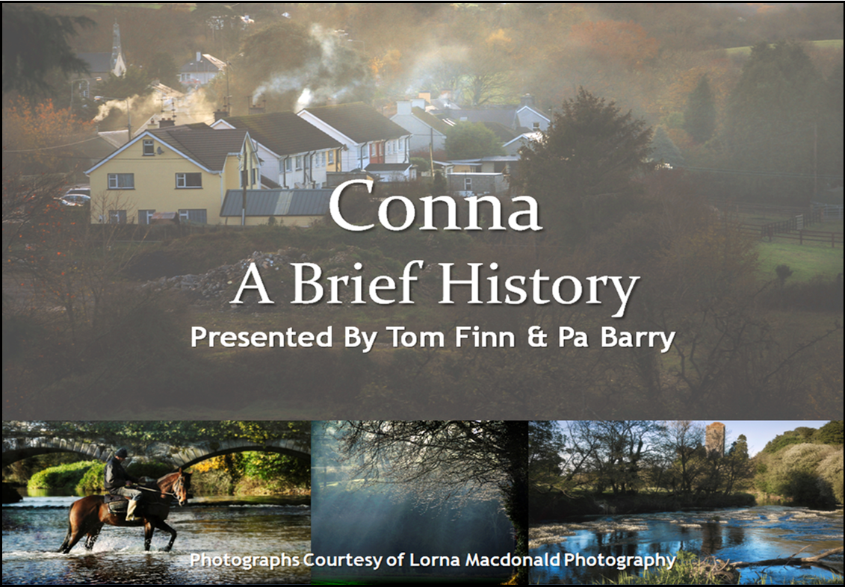
Produced by G Dunlop

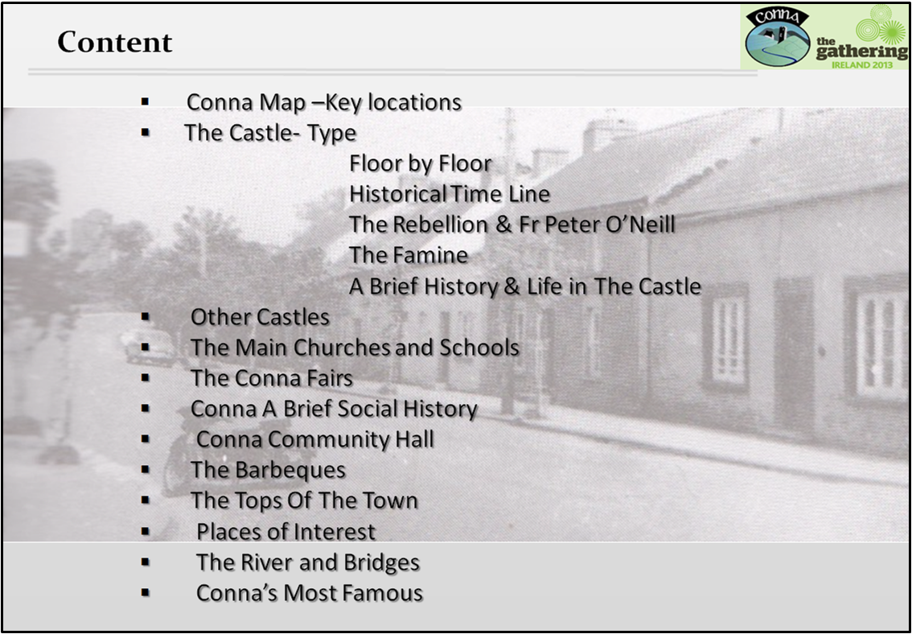
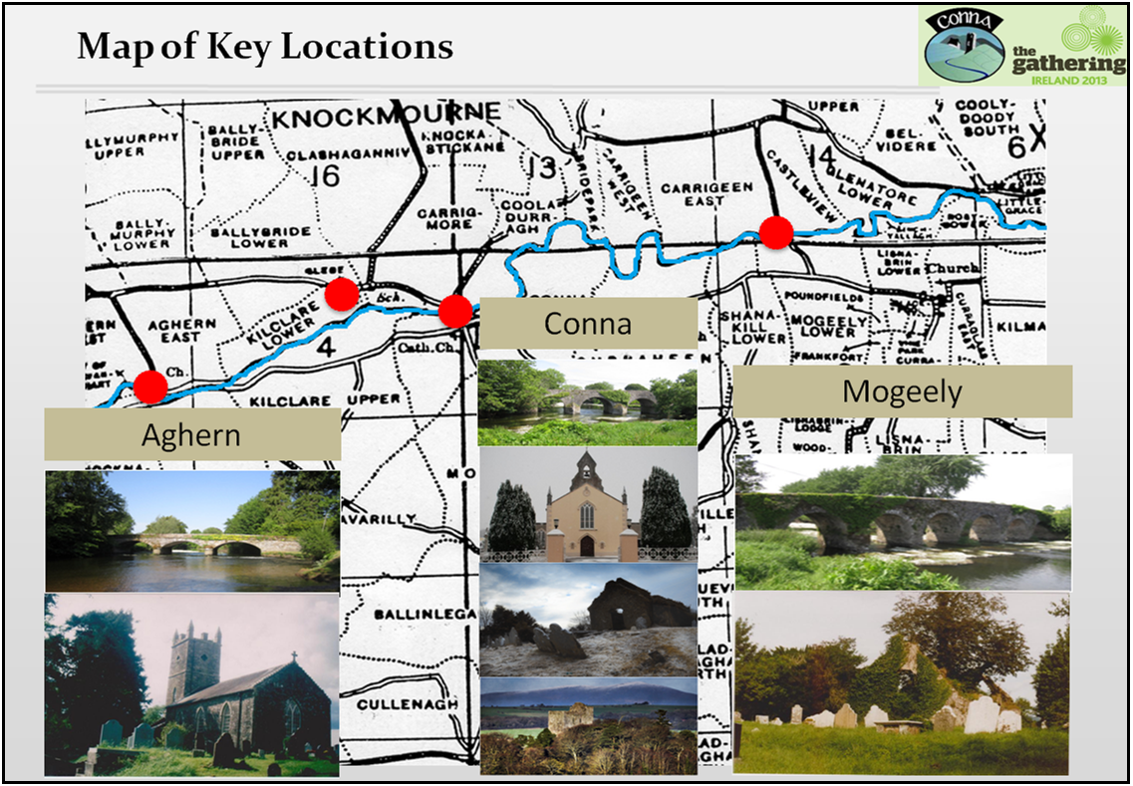

Conna Castle
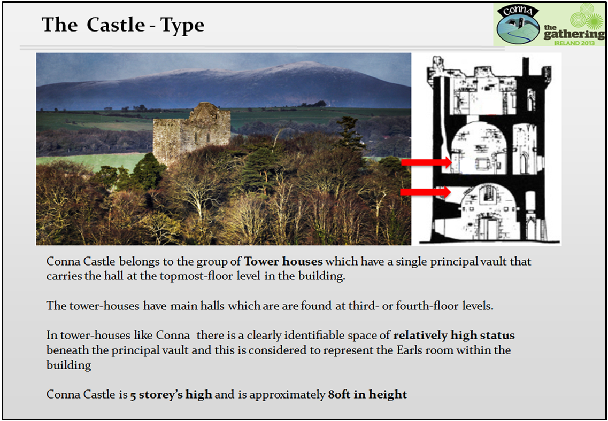
To put Conna Castle and its history in context it is helpful to give a little background information on the overall situation nationwide.
In early medieval Ireland the country was prosperous, rural and well-settled. Irish monasteries were centres for prayer and learning, but also places of great commerce and wealth.
Ireland was then divided into many small kingdoms called tuatha. Every man who owned land, or was a professional, or was a craftsman was a member of a local assembly called an oenach. These men created policies, declared war or peace on other groups and elected or deposed their kings. The tuath became united for reasons that benefited all. About 80 to 100 groups were in Ireland at any given time.
Kings of a tuath were considered very powerful and so were the clergy and also the Irish poets. Laws of organization were explicit and written in the Brehon Laws between 600 and 900 AD.
From around 800 onwards Ireland was attacked by bands of Viking marauders. The raids continued right through the 9th century and a second major wave began early in the 10th century. The monasteries, as the major centres of population and wealth, were the main target of the Vikings. They were despoiled of their books and valuables and many of them were burned. These attacks, and attacks by the Irish themselves, contributed to the decline of the great monastic tradition at this period.
By the 12th century, Ireland was a country of divided kingdoms. Power was in the hands of a few regional dynasties, and these dynasties fought each other for control of all Ireland.
One king, Diarmid, was exiled by a group of Irish forces. He fled to Normandy. He got permission from Henry II of England to use his subjects in order to regain his kingdom. Most importantly, he obtained the support of a Norman called Strongbow.
In 1169 a huge force of Anglo Normans, along with mercenaries consisting of Welsh and Flemish, landed in Wexford. Within a short time Leinster, Waterford and Dublin were under Diarmaid’s control
The Anglo Norman invasion resulted in the creation of borough towns, numerous castles and churches, importing tenants, and an increase in agriculture and commerce. These changes became permanent. Anglo Normans had acquired the Irish language and customs. On the other hand many Irish, especially those in Leinster and Munster, have Anglo Norman surnames.
Ireland, during the period 1536–1691, saw the first full conquest of the island by England and its colonization with Protestant settlers from Britain.
This period also saw the transformation of Irish society from a stateless, clan based Gaelic structure to a state governed society, more like those found elsewhere in Europe. The period is bounded by the dates 1536, when Henry VIII of England deposed the Fitzgerald dynasty as Lords Deputies of Ireland. The new Kingdom of Ireland was declared by Henry VIII in 1541.
Henry VIII decided to extend his rule over Ireland as well as England. He did this by either negotiating or fighting with the independent Irish Kings and lords. This took nearly a century to achieve, and the re-conquest was accompanied by a great deal of bloodshed, as it led to the assimilation – sometimes abolition – of lordships that had been independent for several hundred years.

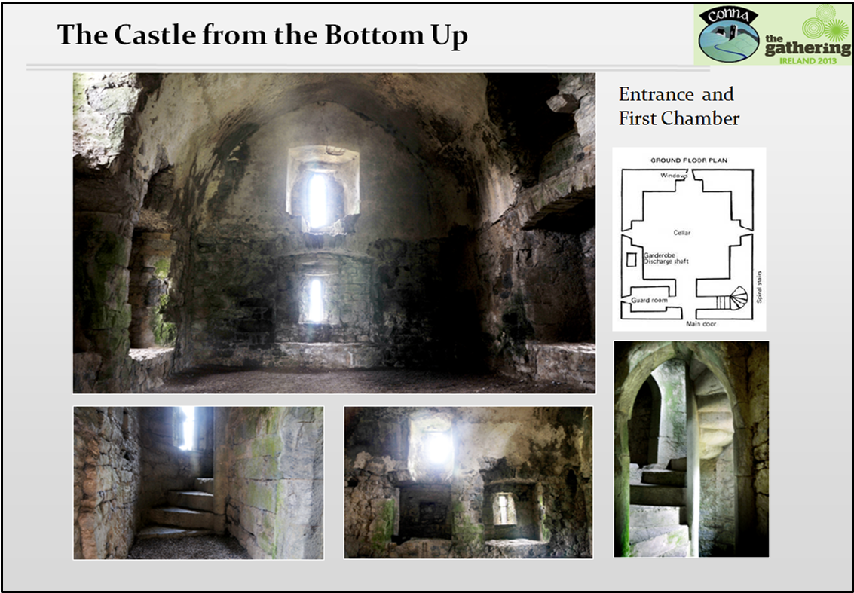
Access is gained to the castle through the ground floor entrance door on the east wall which still retains a yett hole on its left side.
Inside the door a spiral stone staircase winds its way up to the 4th floor in a clockwise direction. This is to suit the defenders of the castle who would normally be right handed. Six narrow slit windows light this staircase.
On ascending the stairs one finds four small mural chambers or bedrooms on the eastern side and five large chambers on the west.
The chamber on the second floor is known as the Earl’s Room. Above this is the Banqueting Hall. Originally there was an extra timber floor in each chamber
There are two garderobes or toilets on the east of the building. The waste drops down a chute inside the north wall with an external opening at ground level. This was a medieval latrine or toilet and the waste just dropped down to the bottom.
The link between sewerage and disease wasn't made until the 18th century, and medieval people remained blissfully ignorant about the health consequences of poor toilet hygiene.
High up over the doorway on the 4th floor is a menacing hooded machicolation or murder hole. Boiling water or oil etc. was dropped from here on top of enemies at the door.
A higher portion of the east side contains an elevated watch tower with windows facing east and north. From these the castles of Shean, Mogeely, Kilmacow and Lisfinny were visible.

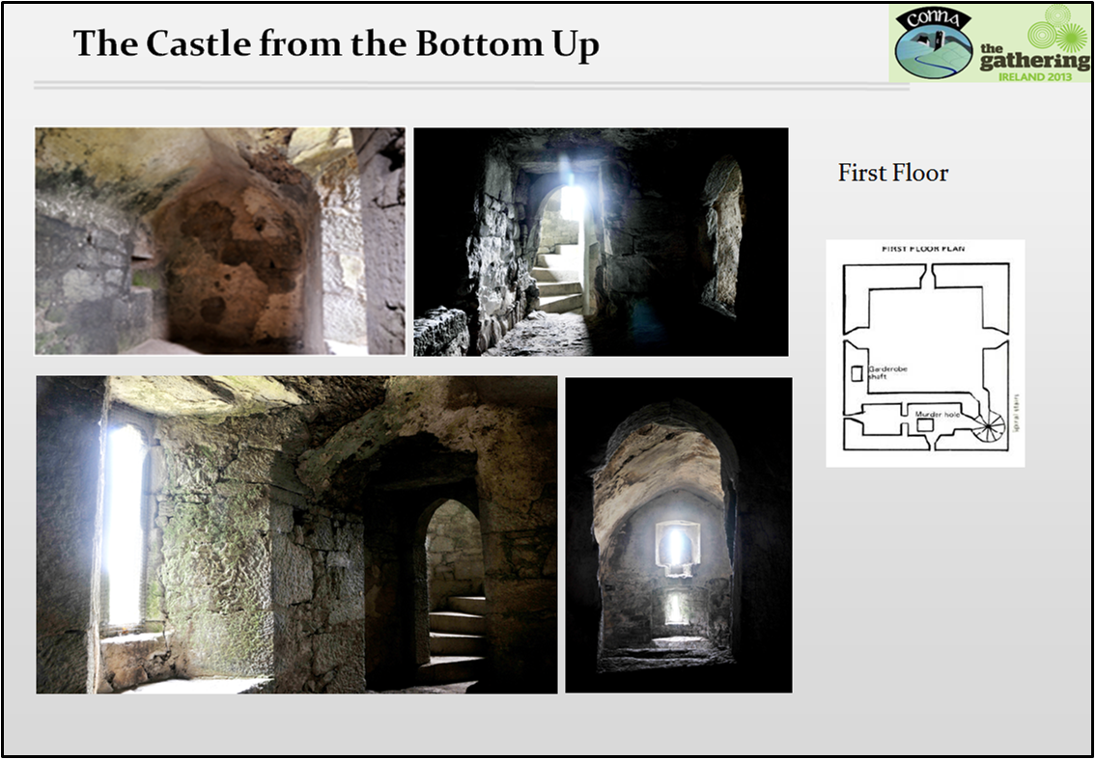
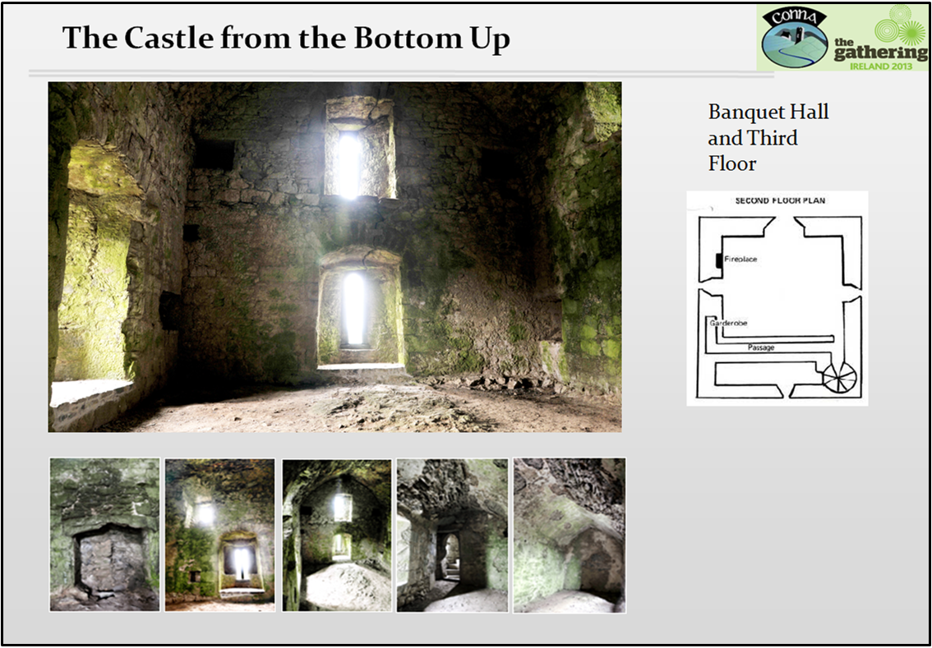
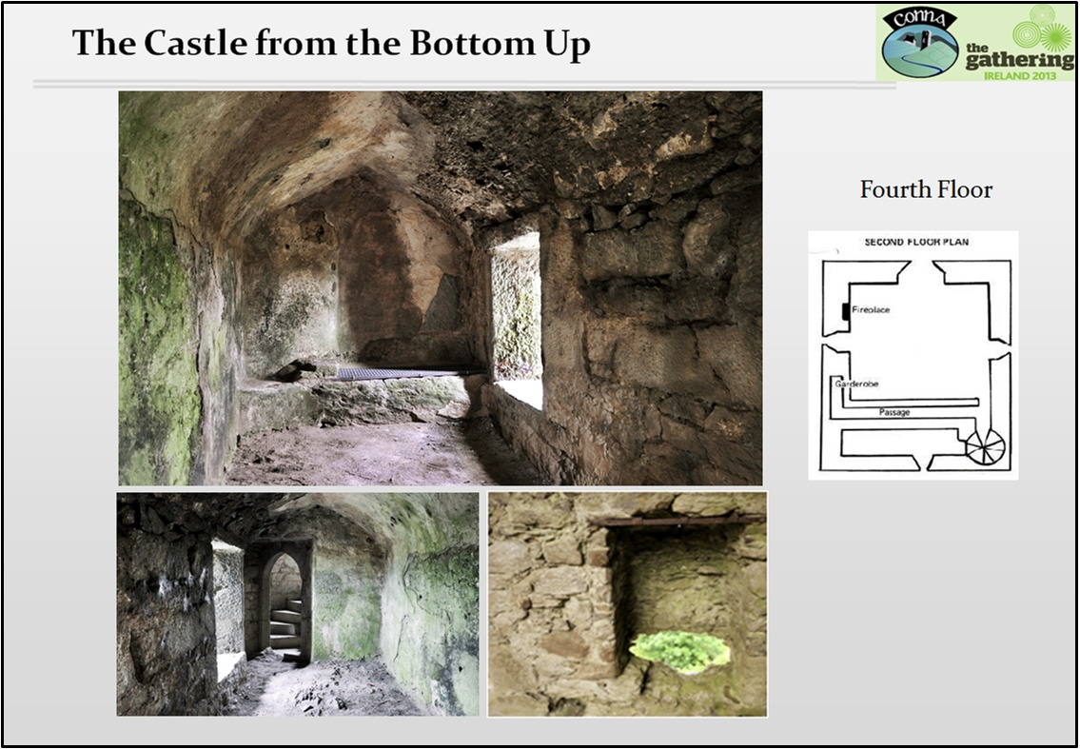
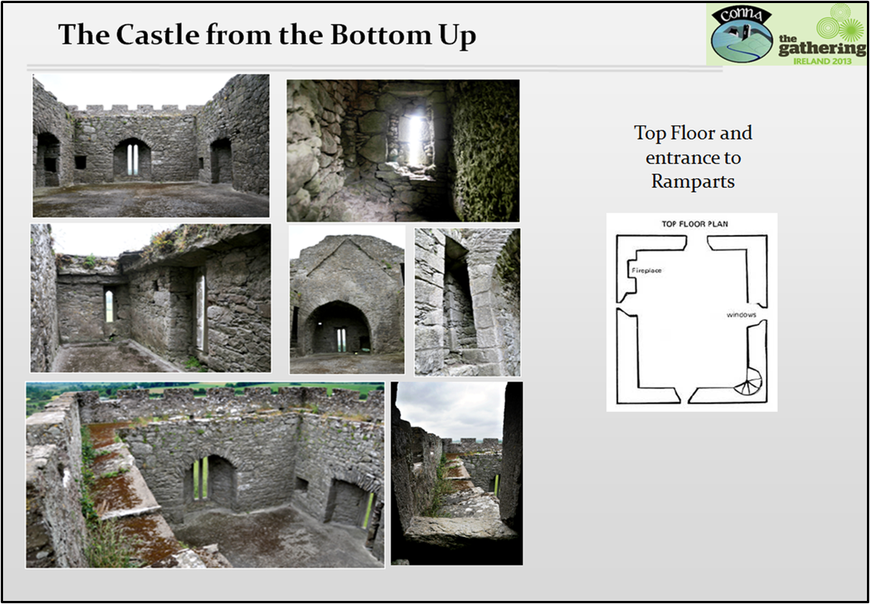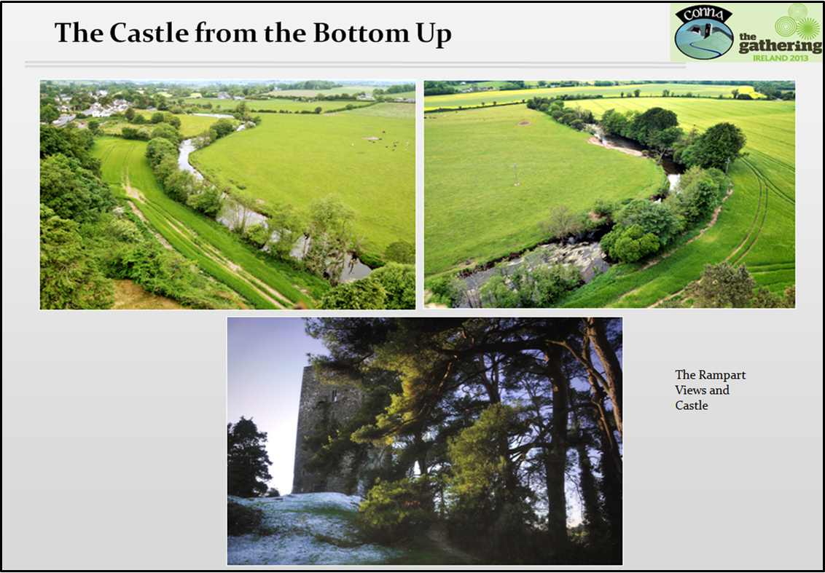
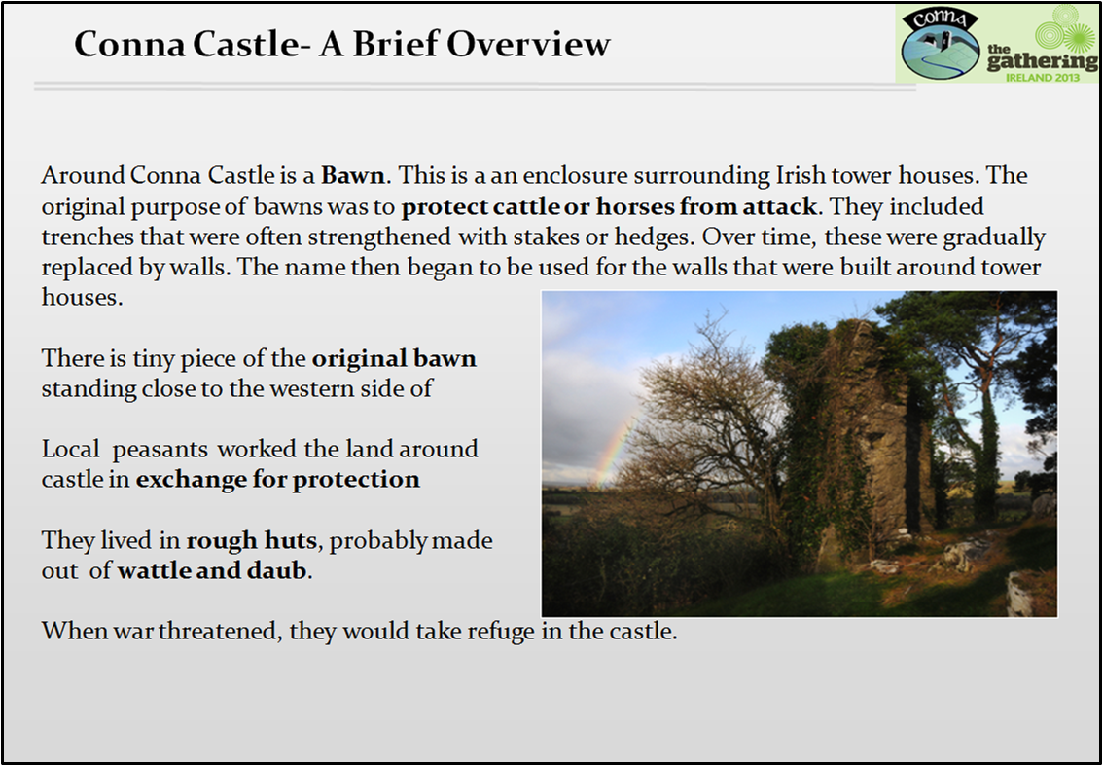
Around Conna Castle is a Bawn. This is a defensive wall or enclosure surrounding Irish tower houses. The original purpose of bawns was to protect cattle from attack. They were enclosed by trenches that were often strengthened with stakes or hedges. Over time, these were gradually replaced by walls. The name then began to be used for the walls that were built around tower houses.
There is tiny piece of the original bawn still standing close to the north western side of the castle.

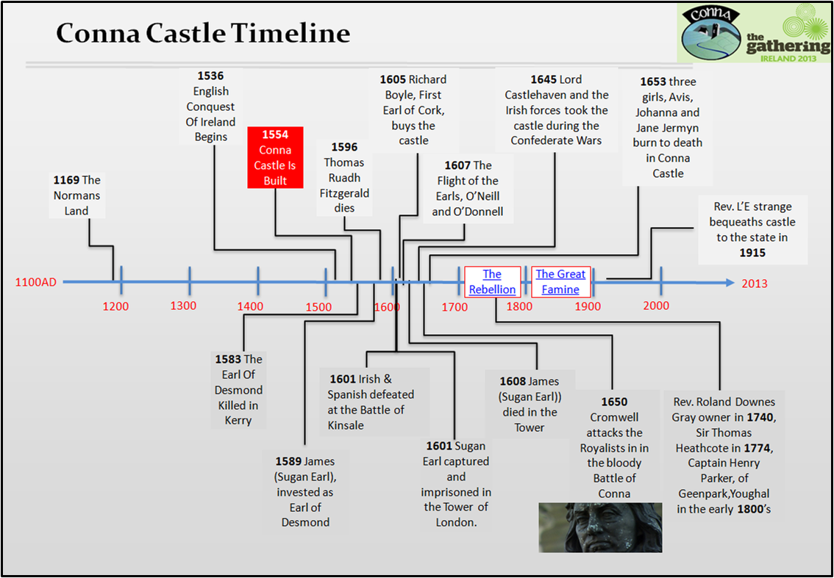
1169: The Anglo-Normans landed in Wexford, a significant date in Irish history.
1536: Henry VIII deposed the Fitzgerald dynasty as Lords Protectors of Ireland. This period also saw the first full conquest of Ireland by England and its colonisation by Protestant settlers from Britain.
1554: Conna Castle was built in 1554 by Thomas Ruadh Fitzgerald, son of James, 14th Earl of Desmond. The Fitzgeralds were descended from Maurice Fitzgerald who landed with the Anglo-Normans in 1169. Thomas Ruadh did not get his inheritance as 15th Earl because Queen Elizabeth 1 declared him illegitimate and gave the title to his half-brother Gerald. Instead Thomas Ruadh was given lands in the greater part of the tiny Barony of Kinnatalloon, which comprises most of the parish of Conna. We believe it was at this time that he built Conna Castle. Gerald did not get an oppertunity to enjoy his inheritance as he was soon forced into open rebellion against Elizabethan adventurers trying to steal his lands. Interestingly, Thomas Ruadh fought alongside him in many of his battles.
1583: Gerald was tracked down to a house near Tralee, Co Kerry and killed. His head was cut off, pickled, put in an earthenware pot and sent to the Queen who set it on a spike on London Bridge.
1589: Thomas Ruadh had a son, James, who was born in Conna Castle. As he grew up he was dismayed by his father’s rejection and disinheritance by the Queen. He repeatedly asked her to make him 16th Earl but she refused. Essentially she wanted to give the lands to the new British settlers and not the old Irish or Anglo-Irish. In 1589 Hugh O’Neill, the powerful Earl of Tyrone, marched south and invested James as Earl. The British always referred to James as the “Sugan Earl” (Earl of Straw) as he was not invested by the Queen.
1596: On January 18th 1596 Thomas Ruadh died in Conna Castle. He died peacefully in contrast to his turbulent life. The funeral procession wound its way down to Youghal where he was buried in the Franciscan Friary which was dissolved a little earlier by Henry VIII during the Reformation.
1601. The combined Irish and Spanish forces were defeated by the British forces at the Battle of Kinsale in 1601. Earl Hugh O’Neill and Red Hugh O’Donnell were with the Irish contingent. It was the ultimate battle in England’s conquest over Gaelic Ireland.
1601: Despite some notable initial successes by James against the British, the tide turned against him. There was a reward of £1,000 on his head. On May 29th 1601 he was captured in the Mitchelstown Caves by the White Knight. He was brought to Shandon Castle in Cork where he was tried and adjudged a traitor. He was sent to prison in the Tower of London in August. He wasn’t executed because the British didn’t want someone elected to succeed him.
1605: Richard Boyle, later 1st Earl of Cork, bought Conna Castle from James Fullerton. He repaired the castle, damaged by the Earl of Essex in 1599 during his disastrous camaign. He also built Conna Bridge and established iron works between Curraglass and Tallow.
1607: On 14th September 1607 Hugh O’Neill and other powerful Irish Lords, accompanied by 90 followers, left Ireland. This was known as the Flight of the Earls. They sailed from Rathmullan on the shores of Lough Swilly to the continent in the hope of returning with Spanish help. However this never happened and they died in exile.
1608: James Fitzgerald, the Sugan Earl, died in the Tower of London and was interred in the chapel there. Some say he died insane. It was the sad end for a most colourful and controversial character.
On June 15th 1645 Lord Castlehaven attacked the castle during the Confederate Wars. Some were killed and others hanged.
On January 30th 1650 Cromwell and his forces attacked the Royalists in what was known as “The Battle of Conna”. He had rested for the winter in Youghal and then marched out to Conna. The Royalists were driven back after a long and bloody battle and those who were not killed took refuge in the castle. Cromwell’s parliamentary forces then withdrew.
In 1653 three sisters, Avis, Johanna and Jane Jermyn were burnt to death in a fire in Conna Castle. They were buried in Knockmourne graveyard. The headstone said “They went up to heaven, like Elijah, in a chariot of fire”.
1740: The Earl of Cork’s interest in the castle passed to Rev Downes Gray in 1740. Sir Thomas Heathcote was listed as owner in 1774. Next it passed to Captain Henry Parker of Green Park Youghal in the early 1800’s.
The castle was purchased from Captain Parker by Hilary L’Estrange in 1851. He built the Courthouse, the Old Post Office and the Dispensary. The castle passed to his wife Mary and later to their son Rev. Alfred L’Estrange in the 1870’s . Rev. L’Estrange wrote a history book called “Conna and Desmond” in the mid 1890’s. On his death in 1915 he bequeathed the castle to the Irish state, the first property to be so willed.

More In-Depth History
Conna Castle was built by Thomas Ruadh Fitzgerald, son of James Fitzgerald, 14th Earl of Desmond. Work started on the building of the castle c. 1554 and it took approximately 10 years to complete. This was at the beginning of the reign of Queen Elizabeth 1 (1558-1603).
Thomas Ruadh should have been in line to inherit his father’s title but was denied this because Queen Elizabeth 1 deemed him illegitimate. This was because the 14th Earl rejected his first wife, Joan, daughter of Lord Fermoy, on the grounds of consanguinity. Thomas Ruadh was instead assigned the tiny Barony of Kinnatalloon, which takes up much of the parish of Conna. His half-brother Gerald was declared 15th Earl of Desmond and heir to the vast Desmond estates.
Gerald was involved in a lot of infighting with other chieftains and also the English. He and his brother John were imprisoned in the Tower of London in the late 1560’s. John lived in Mogeely Castle and his property extended over Mogeely, Curraglass and Kilmacow.
In 1570 Thomas Ruadh Fitzgerald and his men were in battle with another chieftain called James Fitz-Morris. It is unclear if this battle was fought in Conna or not. Some of Thomas’ men were killed. Others were captured, of which two of the commanders of the gallowglasses were hanged. It appears that Thomas Ruadh was fighting on the side of the English, possibly with a view to recovering his lost inheritance. At one stage the Queen actually thanked him for his services to the Crown.
On another occasion the rebel Rory McShane attacked Thomas Ruadh at his castle in Conna. His wife and son were imprisoned and Thomas Ruadh was driven into exile for a short time.
John Fitzgerald, brother of Gerald, the 15th Earl of Desmond, was surrounded in a wood in Castlelyons during the Rebellion in 1582. He died of his wounds. His head was sent to Dublin by the English and his body was hung by the heels over the North Gate in Cork city, where it remained for three years.
In 1582, Gerald, the 15th Earl of Desmond, was defeated in battle in Kerry. The following year he and his followers were traced to a house in a glen near Tralee. A soldier rushed into the house and killed the old Earl despite his pleas to spare him. His head was cut off and sent to Queen Elizabeth who had it set on a spike on London Bridge.
Thomas Ruadh Fitzgerald died peacefully in Conna Castle on January 18th 1596 at an old age. There was a long funeral procession into Youghal where he was buried. The cortege arrived at the Franciscan Abbey. The monks had been driven from the monastery by the Dissolution of Henry VIII.
Thomas Ruadh lived a life full of disappointment, rebellion and conflict. He backed the English side against the Irish Chieftains because he probably thought it was his best bet to succeed as Earl of Desmond. In this he was wrong, as the English, instead of restoring his Earldom, merely complained that he was not energetic enough against the insurgents.
The Sugan Earl
James Fitzthomas Fitzgerald , son of Thomas Ruadh was born in Conna Castle. He was dismayed by his father’s rejection and disinheritance. When he reached manhood he decided to do something about the situation. He went to London in 1581to make his case to the Queen. He swore allegiance to her and asked to be made the rightful heir to the Earldom on the death of his uncle Gerald. She said his case should be taken into consideration and in the meanwhile he would be given an allowance of one mark a day. However his plea for restoration was not successful.
Now, upon his father’s death, he again went to London to make another appeal. Again he was rebuffed. It was the policy of the English government to wipe out all the old Irish and Anglo-Irish Lords and Gentry. When James found that he could gain nothing by peaceful pleading he began to consider using force. He noted that the great Irish chieftain Hugh O’Neill was having considerable success in a rebellion in Ulster.
In August 1598 O’Neill defeated the English forces at the Battle of the Yellow Ford. The account of this battle spread like wildfire to the south and straight away James Fitzgerald of Conna took up arms. O’Neill sent down 4,000 troops to aid James and also bestowed on him the honorary title “Earl of Desmond”. He was invested as Earl on October 8th 1589 near Ballingarry, Co. Limerick. The English called him the Sugan Earl (Earl of straw) as the title had not been bestowed by the Queen.
The new Earl and his forces attacked and defeated the enemy in parts of Limerick and Cork, burning out new English planters and causing them to return to England. In a few months James Fizgerald won back much of the territory of his predecessors and enjoyed great popularity. He was now in charge of 8,000 men and Conna became the centre of the movement.
James’ pen was almost as sharp as his sword. He wrote a long letter to the King of Spain saying that “Pharoah was never more tyrannical than the Queen”and that “the English wanted to blot out the remembrance of our posterity and also our old Catholic religion and to swear that the Queen of England is the supreme head of the church. Nero was far inferior to the Queen in cruelty”.
Queen Elizabeth sent over the Earl of Essex to quell the rebellion. Essex, however, was unequal to Hugh O’Neill, even though he had 16,000 men under his command. He was also defeated by the Sugan Earl. He attacked Conna Castle on June 8th 1599 and partially dismantles it as he had difficulty in taking it. Essex returned to England in disgrace, against the Queen’s wishes, and was put to death in 1601.
In 1600 the Queen appointed a new President of Munster, Sir George Carew and set about capturing or defeating the Sugan Earl. Trickery was used to try to make the Sugan Earl look like a traitor. The plot failed and Dermot O’Connor, the commander of O’Neill’s forces in Munster, who was behind the plot, having been bribed by the English, was beheaded.
In October 1600 the English sent James, son of Gerald, late Earl of Desmond, to Ireland. He had been taken from Ireland 21 years before as a hostage for the good behaviour of his father. He was now to be set up provisionally as the Earl of Desmond in opposition to the Sugan Earl by the English in an attempt to pacify Munster. He had been brought up in England as a Protestant and after he had attended a Protestant service in Kilmallock the Irish bitterly rejected him. From that time onwards none of his father’s followers would have anything to do with him. He became the 16th Earl of Desmond, but soon returned to England, where he died in London in obscurity in November 1601.
Meanwhile, the tide was turning against the Sugan Earl and he was being hunted down with £1,000 on his head. However, no one would betray his hiding place for any money. He was also hoping for help to arrive from Spain to help him in his battle. At one stage a servant of his was taken prisoner and promised to lead soldiers to his place of concealment. One of his men warned him and the the Catholic Bishop of Cork and himself, who were in a cabin, made their escape. He was barefoot, not having time to put on his shoes.
In May 1601 he narrowly missed capture at Garryduff Wood in Ballynoe. He was dwelling with a local harper called Dermot Duggan but they outwitted their pursuers and hid in the wood.
Eventually the Sugan Earl was traced to a cave at the foot of the Galtee mountains not far from Clogheen and Mitchelstown. This was on the lands of Fitzgibbon, the White Knight, who was loyal to the Queen. The White Knight approached the cave and apprehended the Earl and his companion. James was taken to Kilbehenny Castle. He was later taken to Cork and delivered up to Sir George Carew, President of Munster at Shandon Castle. This castle was later replaced by the Dominican Friary.
Carew said of him “He was a man most generally beloved of all sorts” and that one year before his apprehension he was “the most potent Geraldine that ever was of any of the Earls of Desmond”.
For his services the White Knight received £1,000. At a session held in Cork the Sugan Earl was adjudged a traitor and on August 14th 1601, together with Florence McCarthy, was sent to the Tower of London. He was not executed because the English feared that if he was, his brother John would assume the title. He died in 1608 and was buried in the Chapel of the Tower.
John assisted the Spanish landing at Kinsale in 1601. Unfortunately the invasion was defeated by the English and they had achieved their objectives of destroying the old Gaelic order, ridding themselves of the clan system and the more troublesome chieftains. The Flight of the Earls, O’Neill and O’Donnell, occurred soon after on 14th September 1607. The subsequent Plantation of Ulster, introducing Protestant settlers from England and Scotland, laid the foundation of today's divided province of Ulster.
The aftermath
Queen Elizabeth granted Conna Castle to Sir John Fitzgerald of Cloyne in 1602. James 1 reversed this on Elizabeth’s death, granting Conna to James Fullerton in 1605, who immediately sold the estate to Richard Boyle, later first Earl of Cork. Boyle set about repairing Conna Castle and in 1610 leased it to Robert Wingfield, eventually giving it to his nephew, John Boyle, in 1639. At the outbreak of the 1641 Rebellion Robert Peach garrisoned the castle for Boyle and during the Confederate Wars it was taken by the Irish forces under the command of Lord Castlehaven on June 15th 1645. Castlehaven’s forces put some of the occupants to the sword and hanged some of the remainder.
During his Irish campaign Cromwell and his forces attacked the Royalists in Conna in January 30th 1650. L’Estrange refers to this as the Battle of Conna. The Royalists made a brave stand and the battle was long and bloody and they suffered great losses. The few that survived the onslaught took refuge within the castle walls. Cromwell then moved his Parliamentary forces to Gallows Hill to the west where he planted his artillery and opened fire on the castle. The damage that was done was mainly to the roof and battlements. It appeared that Cromwell rested in Conna for the night but it is not clear if in fact it was in the castle.
There was a tragic occurrence in the castle in 1653. Apparently the castle was burnt deliberately by some enemy and three ladies lost their lives in the fire. They were named as Avis, Johanna and Jane Jermyn whose father Edward was a friend of the Boyle family. In nearby Knockmourne graveyard there was once a tombstone with an inscription reading “They went up to heaven, like Elijah, in a chariot of fire”. In the ground beneath there was a silver urn containing calcined bones.
The Earl of Cork’s interest in the castle passed to Rev Roland Downes Gray in 1740. Sir Thomas Heathcote was listed as owner in 1774. Next it passed to Captain Henry Parker of Greenpark, Youghal in the early 1800’s. It was purchased from Captain Parker by Hilary L’Estrange in 1851, passing to his wife Mary and later to his son Rev A.G.K. L’Estrange in the 1870’s. On his death in 1915, it was left to the state, the first property to be so willed.

Life in The Castle
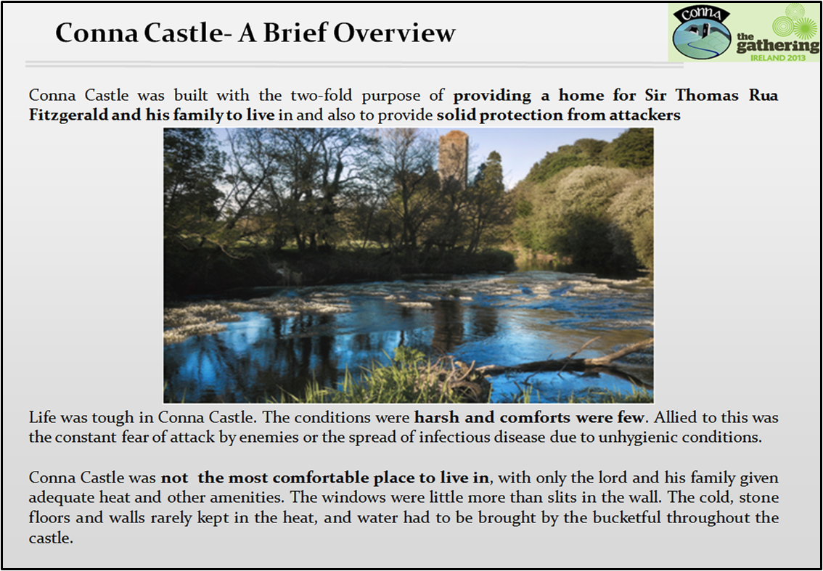
Conna Castle was built with the two-fold purpose of providing a home for the Lord to live in and also to provide solid protection for the inhabitants from outside invaders.
Many people today have a romantic view of castles, complete with knights, and non-stop medieval feasting in the banqueting halls. In reality, however, life was tough in Conna Castle. The conditions were harsh and comforts were few. Allied to this was the constant fear of attack by enemies or the spread of infectious disease due to unhygienic conditions. There was little soap and water then and showers and baths and anti-perspirants were unheard of. Because of this lack of hygiene it is said that an army could sometimes be smelled before it was seen or heard!

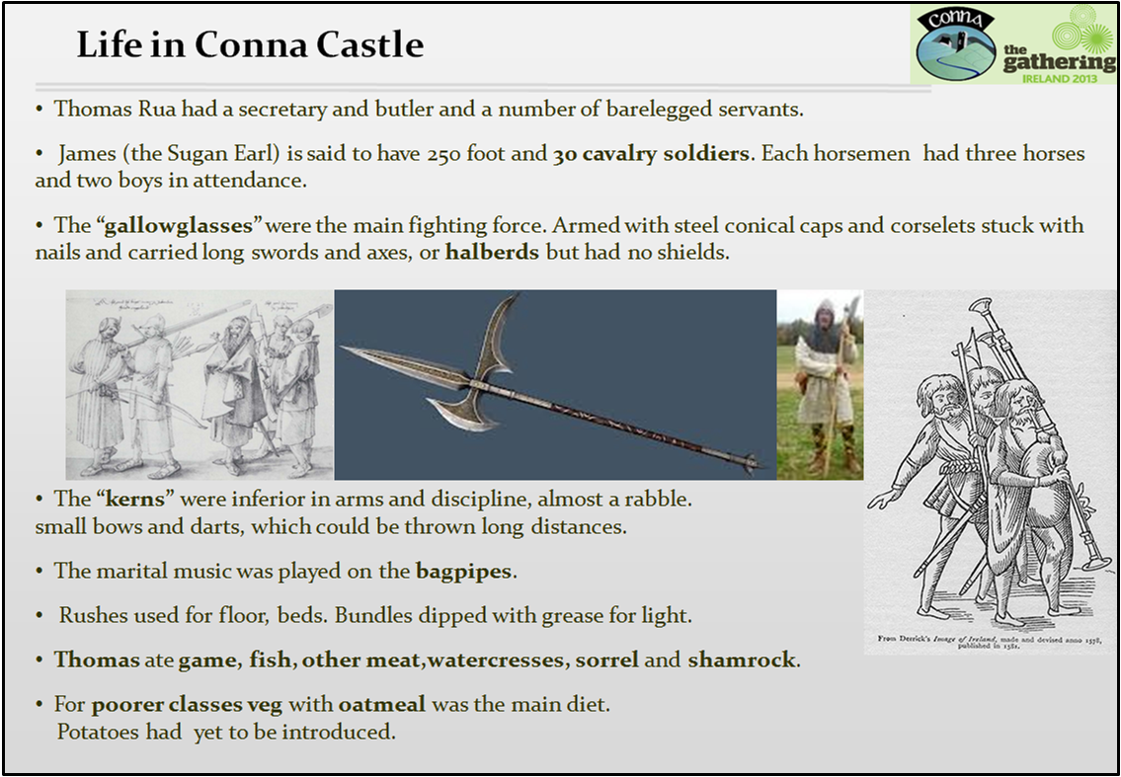
It is likely Thomas Ruadh would also have a harper or other musician in the castle.
The horsemen were all “gentlemen”. They were armed with spears but rode without spurs or stirrups.
The Halberds (axes) had three parts that made up the head. There is the bladed for slicing through armour, the spike for thrusting and the hook that was used to take down armed opponents on horseback as they rode by.
In a book called “The image of Ireland”, published in 1581, there is a picture of a bagpiper. He has long hair, a short beard, a sword, armlets and immense bagpipes.
Thomas Ruadh would have drank some continental wine. However, the usual drink was a type of beer made without hops. Another drink was mead, made of honey and water.
In Conna Thomas Ruadh had to collect a considerable amount of “Munsterowne” or money and victuals, from workmen and builders. There were other dues, such as Coshery, a provision of food and lodgings for the Lord and his retainers; Shragh, a yearly rent in money and Mart, a rent in meat.

The 1798 Rebellion
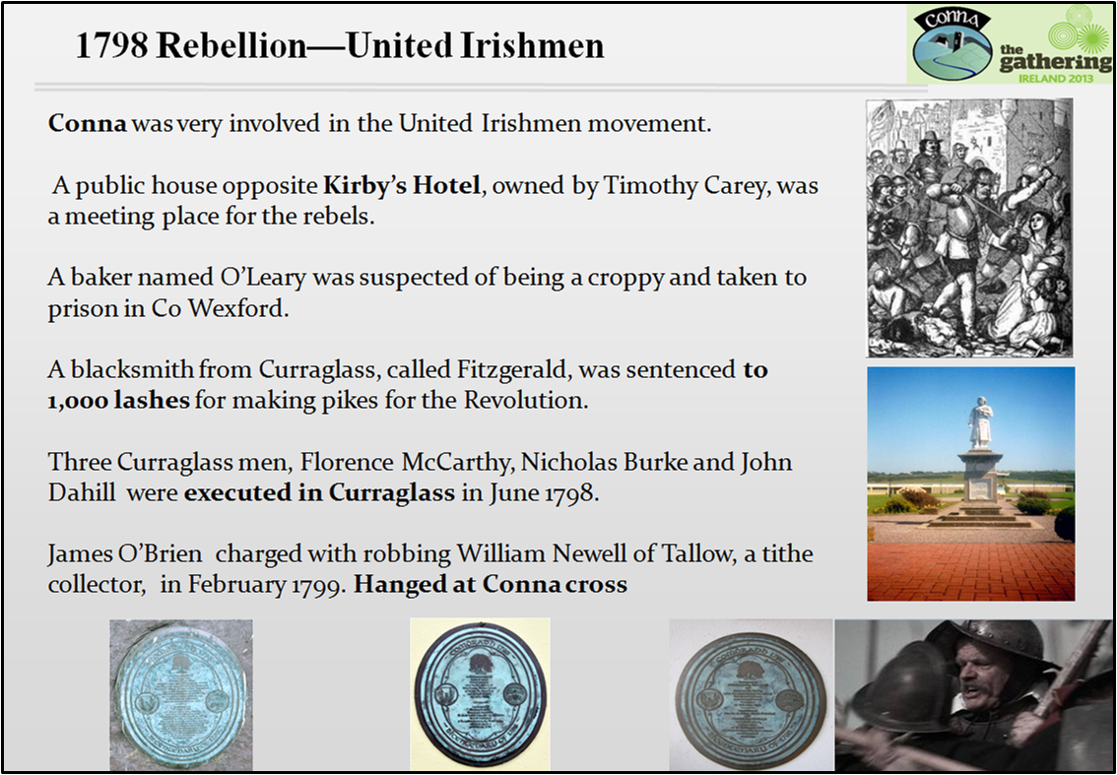
Conna was very involved in the United Irishmen movement. Hundreds of local people were taking the oath and joining the United Irishmen. A public house opposite Kirby’s Hotel in Conna, owned by Timothy Carey was a meeting place for the rebels.
A baker named O’Leary lived in a little house where the Courthouse was later built. He was suspected of being a croppy and taken to prison in Co Wexford. He was whipped and asked to name his associates but he refused. It looked as if he was going to die from the torture and was allowed a visit from his wife. He tricked the warder by disguising himself as his wife and escaping. In reprisal the soldiers went to his house in Conna and burnt it. When some buildings were later being demolished to make way for the Courthouse evidence of smoke damage was clearly seen.
In Curraglass there was a street called Weaver’s Row (now The Mall) and many United Irishmen were hanged there from a large oak tree.
Three Curraglass men, Florence McCarthy, Nicholas Burke and John Dahill were tried and executed for attempting to seduce a yeoman private from his allegiance to the Crown. They were executed in Curraglass in June 1798. A plaque commemorating this event was placed on the wall of the Plough Bar in 1998 by Cork County Council. A blacksmith from Curraglass, called Fitzgerald, was sentenced to 1,000 lashes for making pikes for the Revolution.
A man called James O’Brien was charged with robbing William Newell of Tallow, a tithe collector, of tithe notes, money and a pistol in February 1799. He was hanged for these offences at Conna Cross on April 6th 1799 and his body was ordered to remain suspended for some days afterwards. There is a plaque to his memory outside Tom English’s shop.
An evergreen oak, symbolizing the Tree of Liberty, was planted opposite the entrance door to the Sports Complex in 1998 to commemorate the bicentennial of the 1798 Rebellion. It was joint venture between Cork County Council and Conna History Committee.
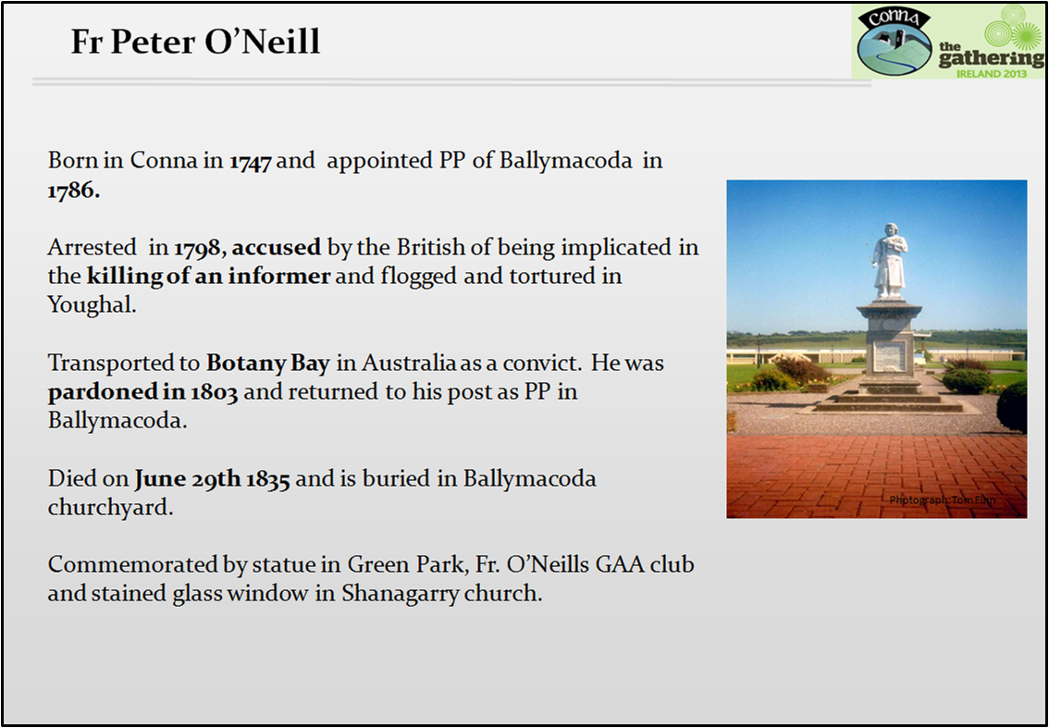
Fr Peter O’Neill was born in Kilclare,Conna in1747. He was educated in Paris. He was appointed Parish Priest of Ballymacoda in 1786. At this time the United Irishmen movement was very active in Ballymacoda parish. A local man was suspected of being a traitor and was executed. Though wholly innocent Fr O’Neill was arrested and accused by the British of being implicated in the killing. He was arrested in 1798 and brought to Youghal. Here he was flogged and unsuccessful attempts were made to make him confess. He was promised his freedom if he revealed the names of the United Irishmen who had confessed to him. He rejected the offer.
Finally a statement was forced from him under torture. He was kept in prison for a time without trial and then transported to Botany Bay in Australia as a convict. He was pardoned in 1803, returned to Ireland and again took up duty as Parish Priest of Ballymacoda. He died on June 29th 1835 and is buried in Ballymacoda churchyard.
Permanent reminders of Fr Peter O’Neill are the large statue that stands at the entrance to Green Park in Youghal and the naming of a GAA club in his name, Fr O’Neills.
He is also depicted in stained glass window in Shanagarry church, which he built in 1814.

He built Ballymacoda church in 1797.
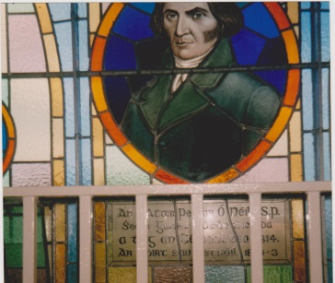
A monument to Fr. O’Neill was erected near the hall in Conna in 1998. It was a united venture by Cork Co. Council and Conna History Committee. This was the site of an old thatched church and it is believed Fr. O’Neill was baptised there.

The Famine
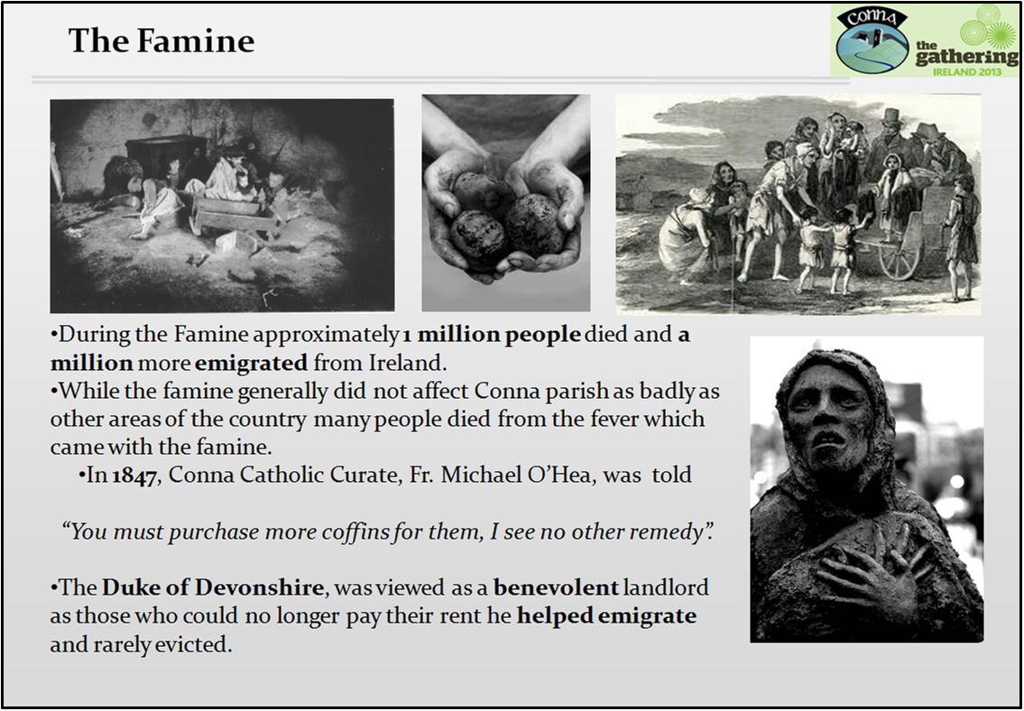
During the Great Famine (1845-1852) approximately one million people died and another million emigrated. The Famine did not affect Conna parish as badly as other areas of the country. However, many people died from the fever which came with the famine. In 1847, Conna Catholic Curate, Fr. Michael O’Hea, asked the chairman of the Fermoy Union of the Board of Guardians what was going to become of the people of Mogeely. The stark reply he got was “You must purchase more coffins for them, I see no other remedy”.
The Duke of Devonshire was viewed as a benevolent landlord. Through his agent, Francis Currey, he tried to balance the needs of the landlord with those of the tenants. Evictions were used only as a last resort. In some cases he gave money to people in dire need so that they could emigrate.
On Friday October 1st 1847 the Cork Examiner newspaper reported the following harrowing account of a case in Curraglass; “While Joe Bennett, his wife and seven children were lying in fever in Curraglass hospital, five or six acres of luxuriant corn stood unprotected in his fields, as one lame child was left at home in their desolate cottage. The agent of Mrs. Bowles of Youghal, his landlady, had the crop cut down, carted and sold for a price not half its value. Meanwhile Joe Bennett recovered and visited his farm to find not a potato nor a grain of corn to feed his family should they recover. Mr Bennett then had a relapse and now lives in hospital with his children with little hope of recovery. Five years ago when he took the farm he was worth three or four hundred pounds and would have been able to pay his rent had he been allowed to sell his crop himself”.

Other Castles
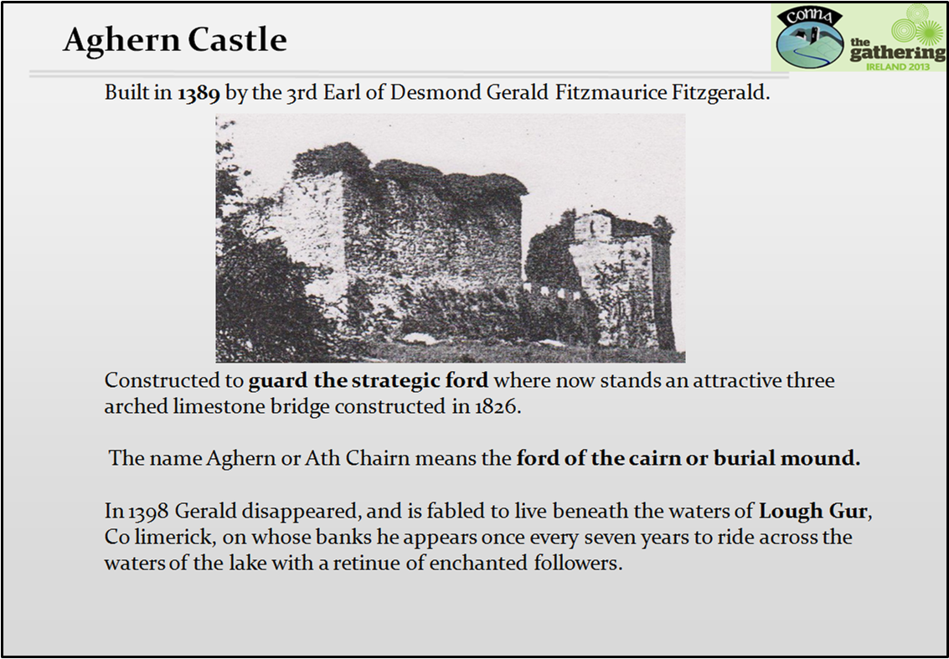
Aghern Castle is reputed to have been built in 1389 by the 4th Earl of Desmond, Gerald Fitzgerald. It was constructed to guard the strategic ford where now stands an attractive three arched limestone bridge, constructed in 1826.
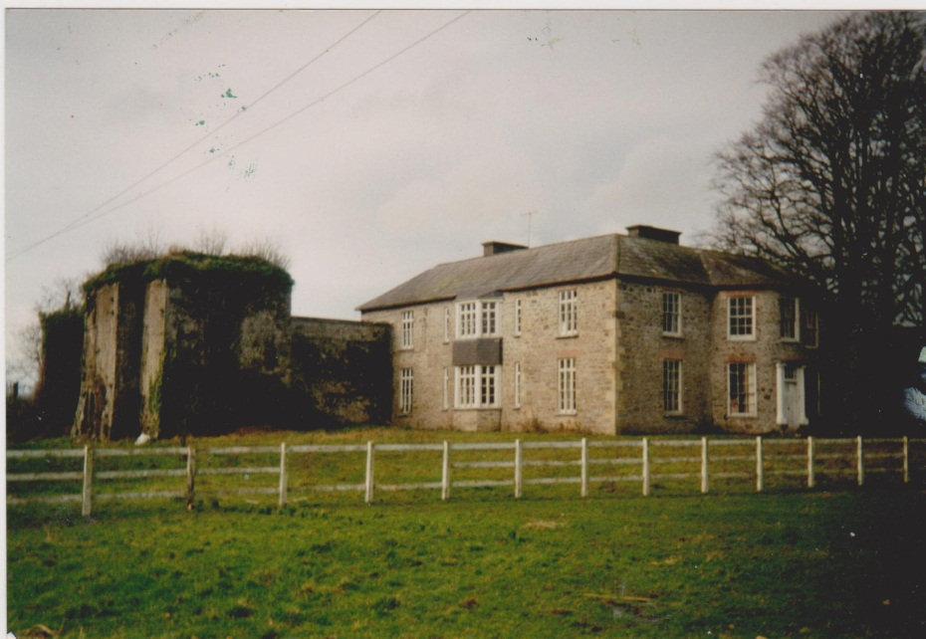
The name Aghern or Ath Chairn means the ford of the cairn or burial mound. Much of the castle is in ruins but there is evidence to suggest that the original castle was a strongly fortified structure.
Gerald Fitzgerald, who built the castle, had been appointed Justiciar of Ireland in 1367 and is believed to have died in 1398.
The Fitzgeralds held Aghern Castle until the end of the Desmond Rebellion against Queen Elizabeth. The Sugan Earl of Conna did offer some hope with his spirited opposition but after his capture in 1601 Aghern Castle, like Conna Castle, was confiscated from the Fitzgeralds and granted to Sir Thomas Fullerton, who immediately sold it to Richard Boyle, later the 1st Earl of Cork.
According to legend, the 4th Earl of Desmond disappeared beneath the waters of Lough Gur in Co. Limerick from where he emerges once every 7 years to ride across the waters of the lake with a retinue of enchanted followers. Apparently Gerald was interested in paranormal matters and the occult and this is why the myth emerged.

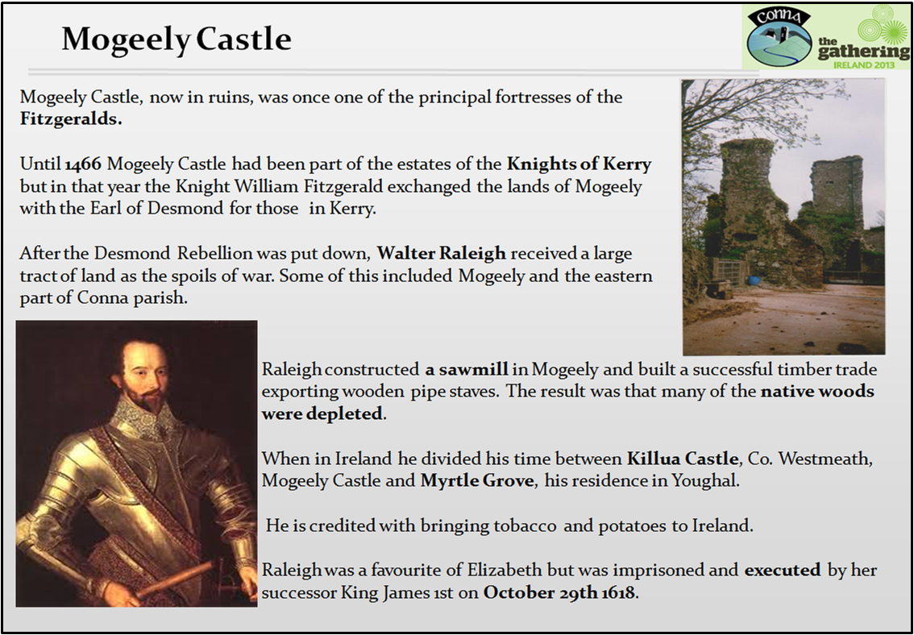
In 1467 Thomas, Earl of Desmond (The Great Earl) was beheaded in Drogheda because of his enmity with Edward 4th. His sons went into rebellion and could only be pacified with the promise of further land. This was during the time of the War of the Roses in England and the King could not afford to have a dangerous enemy at his back.
The result of the Desmond Rebellion was the destruction of the Desmond dynasty, the confiscation of land by the Crown and the subsequent colonisation of this land with English and Scottish settlers.
There is a story told about Walter Raleigh in relation to his introduction of tobacco into Ireland. One day he was seated in his garden in Youghal smoking. A servant who had observed him rushed in and threw a bucket of water over his head, fearing he was on fire!
Raleigh was an all-rounder. He was a writer, a poet, a courier and an explorer.
A change of monarch in England proved his undoing. Elizabeth admired him but her successor James 1 imprisoned him for allegedly plotting against him. He was then released to lead an expedition in search of El Dorado (The city of Gold) in South America. He was unsuccessful and returned to England. The King had him thrown in prison for some perceived insult against the Spanish and executed him in 1618.

The Churches
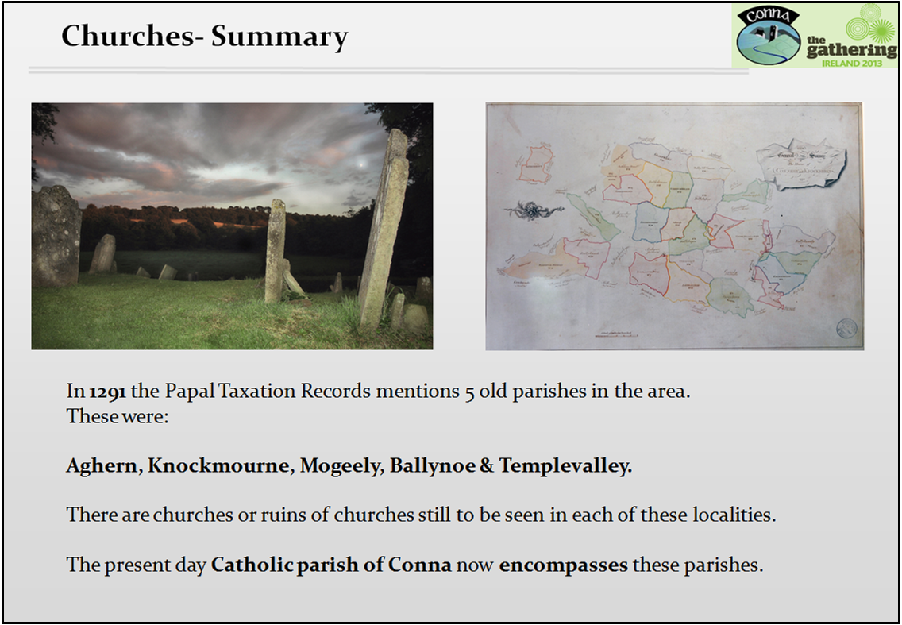
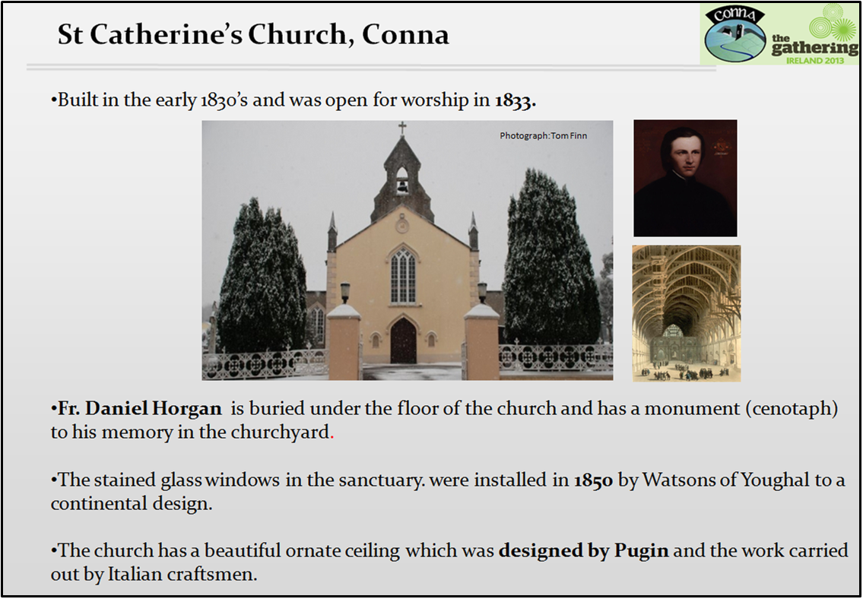
The building of the church was initiated by Fr. Maurice Sheehan P.P. who resided in Curraglass and completed by Fr. Daniel Horgan P.P. The altar was erected to the memory of Dr John Hutch G.P by parishioners as a mark of their appreciation.
Augustus Pugin who designed the church’s ornate ceiling was an English architect and is chiefly remembered for his work on the Palace of Westminster.
The forerunner of the present church was an L-shaped thatched building on a site called the Paddock or Chapel Field. This plot was later donated by the Barry family to the newly formed Conna Guild of Muintir na Tire on which they built their community hall in 1945.

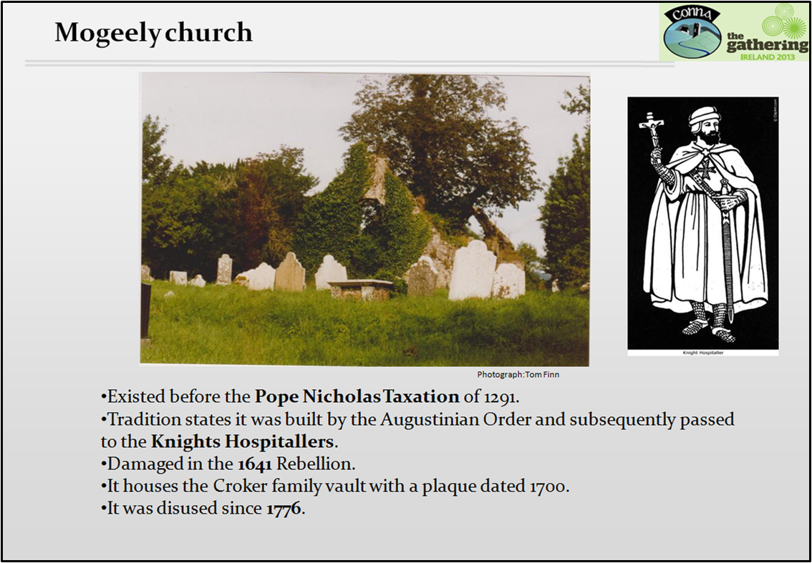
The Pope Nicholas Taxation of 1291 indicates that a church had existed here before that year and consequently long before the coming of the Earls. Tradition says that the church was founded by the Augustinian Order, subsequently passing to the Knights Hospitallers. However there is no documentary evidence to support this. The church was disused since 1776.
The Lewis Topographical Dictionary of Ireland (1837) states that Mogeely church “was destroyed in the War of 1641”.
On the north wall of the nave there was a vestry. This later became the Croker family vault and was entered through a heavy iron gate. The Croker family resided in Lisnabrin House. The last of the Crokers was Dr. Edward Croker who died on August 9th 1901. On the wall of the mausoleum is an inscription which reads; “Here also lyeth y body of Walter Croker of Lisnabrin in this parish who died in y 65 year of his age on y 23rd br. A.D. 17OO”.
Jack Pyne, son of Henry Pyne, was buried in Mogeely churchyard. He was Walter Raleigh’s agent and partner in his timber business who got a lease of Mogeely Castle and lands from him.
Folklore tells us that a local man was buried in Mogeely churchyard directly beneath the footpath leading to the old church. Apparently he had committed some despicable crime and was so buried that people constantly walked over his grave.
An apostate friar named Burdon was Rector of Mogeely. One of Peter O’Neill’s uncles was buried there and afterwards one of the brothers was upset. He said his brother could not rest quietly in his grave as he would be annoyed every Sunday by the Psalm singing of the apostate. He would not mind if it were a natural Protestant parson. That night the church was unroofed and remained so up to the present.
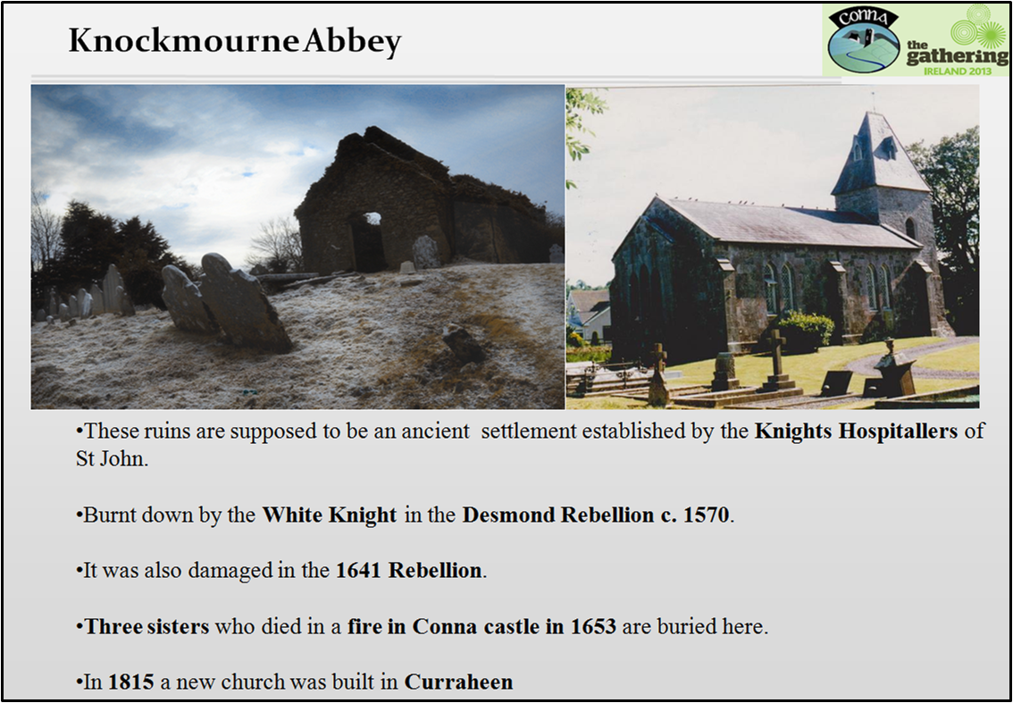
According to L’Estrange the Knockmourne ruins are supposed to be an ancient settlement established by the Knights Hospitallers of St John. However there is no evidence to support this and it is now believed L’Estrange confused this old church with Mourneabbey, near Mallow, which indeed was founded by the Knights Hospitallers. Knockmourne church was built in the 12th century and was entirely burnt down by the White Knight in the Desmond Rebellion c. 1570. It was later restored but in 1694 it is recorded that “The church of Knockmourne was burnt by the Irish in the late war” (i.e. 1641). By 1774 it was in repair and had a west gable inserted and also a chancel (presbytery) built at the east end.
Three sisters, Avis, Johanna and Jane Jermyn, who died in a fire in Conna Castle in 1653 are buried in the churchyard. Rev L’Estrange says that in 1850 Rev Thomas Spread Campion, Vicar of Knockmourne , found an old tombstone sacred to the memory of the three ladies. The inscription says that “they went up to heaven, like Elijah, in a chariot of fire”. In the ground beneath he discovered a silver urn, containing calcined bones.
Church of Ireland services were held in the building up to the end of the 18th century. Later a little schoolhouse near the graveyard gate was used as well as the Market House until a new church was built in Curraheen (St Lukes) in 1815.

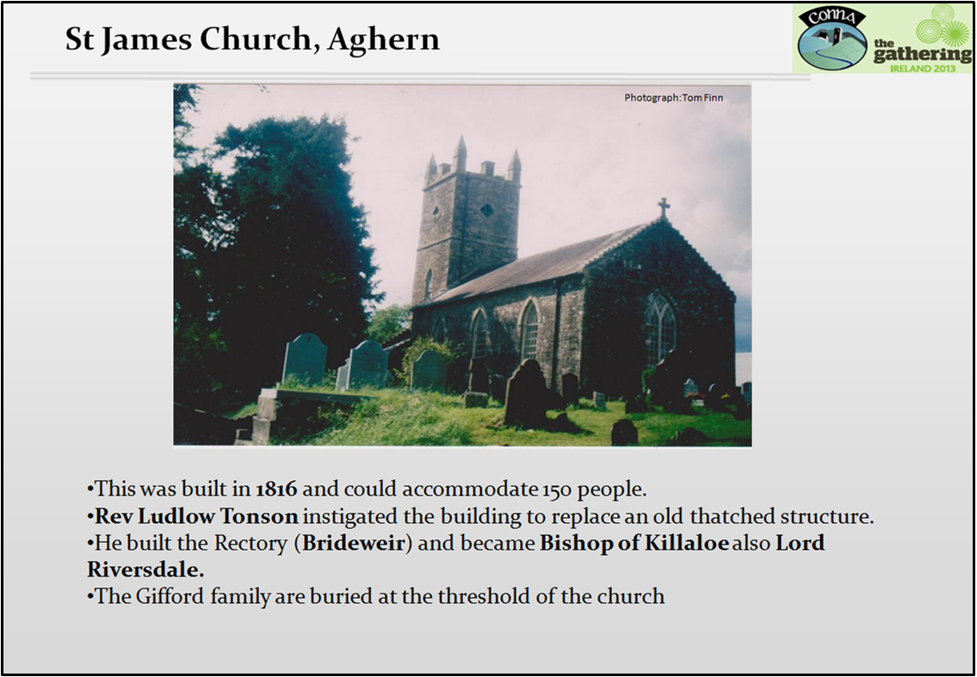
When the Rev. Ludlow Tonson was appointed as Vicar of Aghern Union in 1814 he found the existing thatched church in a ruinous condition. With generous donations he set about building a new church. This was opened in May 1817 and was dedicated to St James. It was capable of accommodating 150 people.
Rev. Tonson, who had resided in Lisnagar, Rathcormac built the vicerage in 1822. He left the parish in 1839 and became the Bishop of Killaloe. In 1848 he became Lord Riversdale. The Vicerage was purchased by Eaton William Waters in 1905 and he renamed the property Brideweir.
The names of the first rectors of the church are inscribed on the bell. Originally the church had box pews with family nameplates.
The picturesque little church was closed for service in 1991 due to falling attendances. It was later acquired by Aghern Church and Graveyard Restoration Committee who are repairing it. They hold regular community events such as Carol Singing at Christmas.
The Giffords, who were a well known family on the area built Aghern House and owned a large tract of land nearby. The townland Mount Gifford is named after them..

Schools
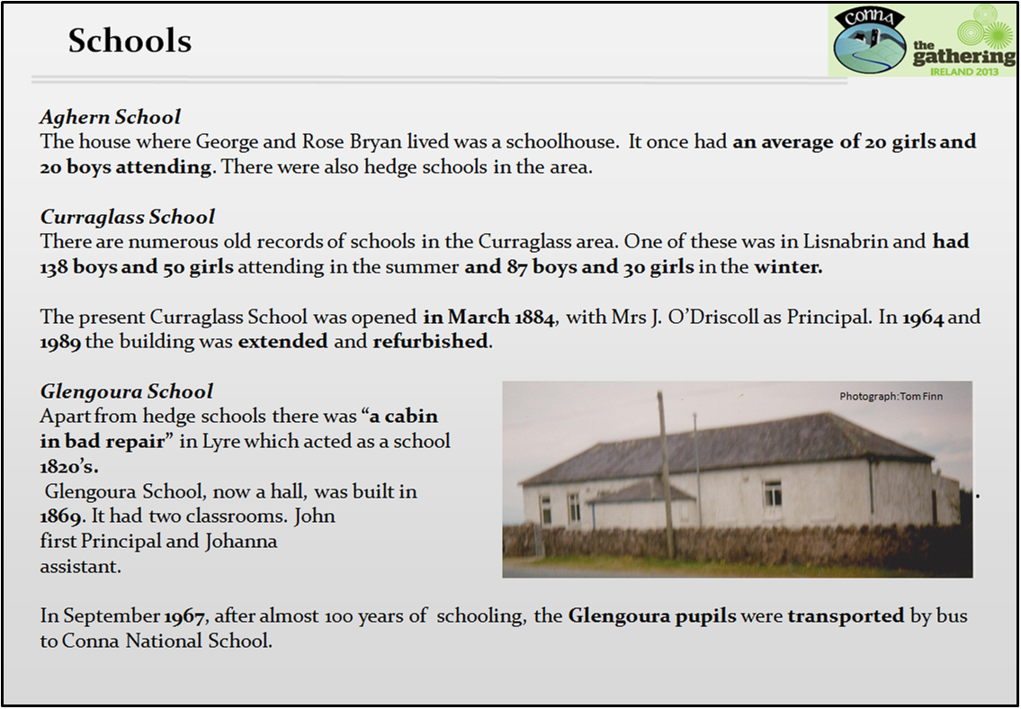
Due to the Penal Laws 1695-1782 Catholics were not allowed access to education. Because of this only hedge schools existed during that period.
The National Board of Education was set up in 1851and schools as we know them today are a result of that.
Aghern School
The house where George and Rose Bryan lived was a schoolhouse. It once had an average of 20 girls and 20 boys attending. There were also hedge schools in the area.
Curraglass School
There are numerous old records of schools in the Curraglass area. One of these was in Lisnabrin and had 138 boys and 50 girls attending in the summer and 87 boys and 30 girls in the winter.
The present Curraglass School was opened in March 1884, with Mrs J. O’Driscoll as Principal. In 1964 and 1989 the building was extended and refurbished.
Curraglass School was burnt on Ash Wednesday 1942 and for a time classes were held in nearby Vinepark House.
Glengoura School
Apart from hedge schools there was “a cabin in bad repair” in Lyre which acted as a school in the 1820’s.
Glengoura School, now a hall, was built in Lacken c. 1869. It had two classrooms. John Hickey was the Principal and Johanna Noonan his assistant.
In September 1967, after almost 100 years of schooling, the Glengoura pupils were transported by bus to Conna National School. The building is now used as a community hall.

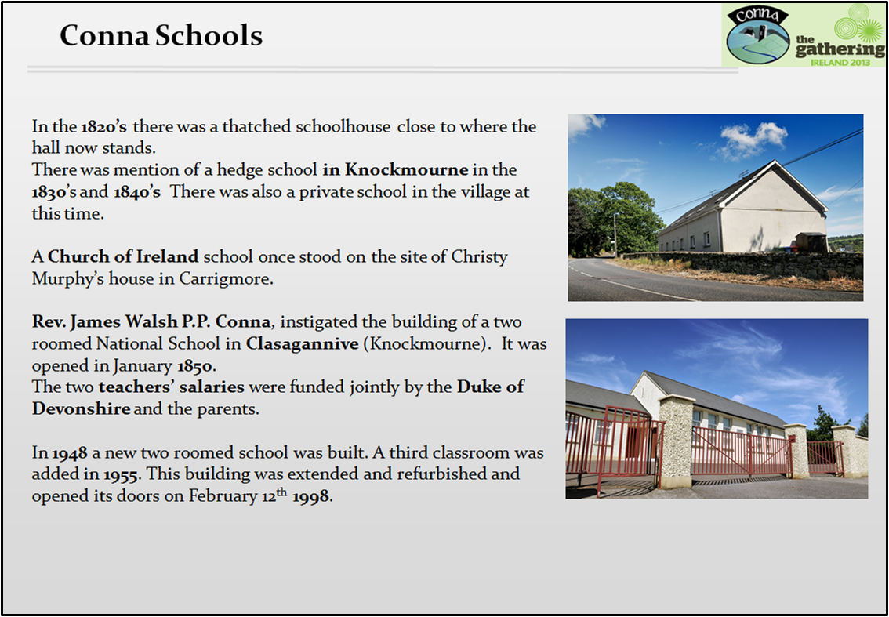
In the 1820’s there was a thatched schoolhouse close to where the hall now stands. There were 160 pupils on the Rolls. There was mention of a hedge school in Knockmourne in the 1830’s. In the 1840’s there is a record of a school just to the west of this hedge school. There was also a private school in the village at this time. A Church of Ireland school once stood on the site of Christy Murphy’s house in Carrigmore and the teacher and his family lived on the premises.
Rev. James Walsh P.P. Conna, instigated the building of a two roomed National School in Clasagannive (Knockmourne). It was opened in January 1850. Boys and girls were segregated inside in the school and in the playground.The two teachers’ salaries were funded jointly by the Duke of Devonshire and the parents.
In 1948 a new two roomed school was built where the present structure stands by O’Leary Builders Fermoy. A third classroom together with flush toilets, a play shelter and a water tower was added in 1955. This building was totally refurbished and extended in 1998.The new building was constructed by O’Sheas Builders, Cork and opened its doors on February 12th1998.

Fairs in Conna
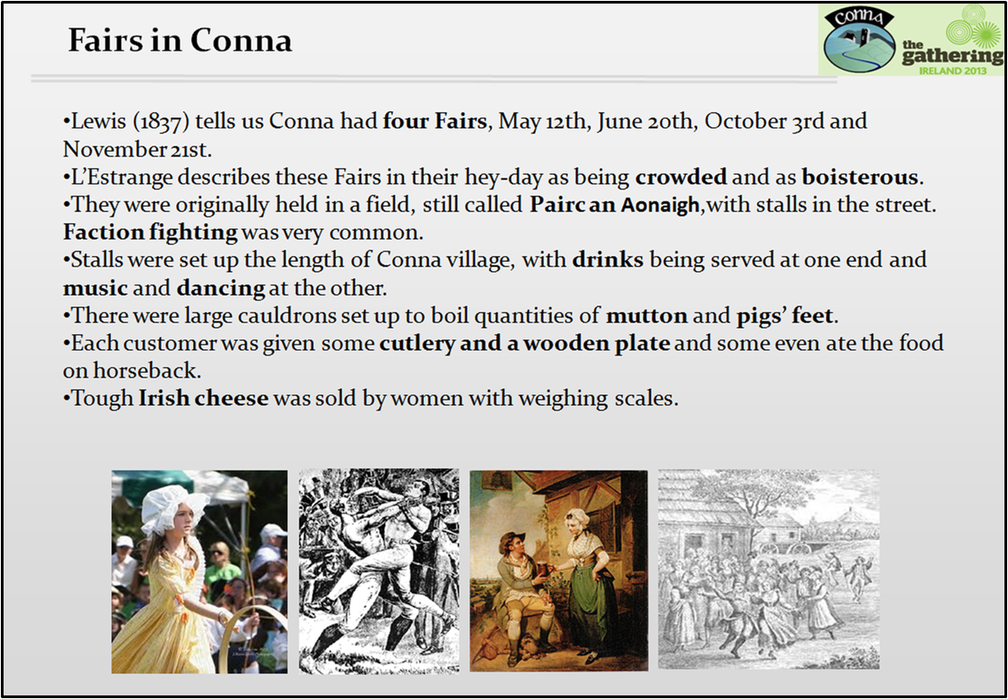
Lewis (1837) tells us Conna had four Fairs, May 12th, June 20th, October 3rd and November 21st. L’Estrange describes these Fairs in their hey-day as being crowded and as boisterous. They were originally held in a field still called Pairc an Aonigh, which is located up Conna Hill. They were later held in the field opposite the church. Faction fighting was very common. After the fighting had subsided, it was not unusual for the adversaries to retire to the neighbouring public houses and “spend the evening together in harmony”.
Stalls were set up the length of the village, with drinks being served at one end and music and dancing at the other. Conna was noted for its dancers in the early part of the 19th century. There were sometimes up to 60 tents and stalls at the fair and some extended from the old post office towards the castle. There were large cauldrons set up to boil quantities of mutton and pigs’ feet. Each customer was given some cutlery and a wooden plate and some ate the food on horseback. Tough Irish cheese was sold by women with weighing scales. Mutton pies were sold and customers were given plates so they could pour gravy over the pie.
Like many gatherings it was a great opportunity for tricksters and petty thieves. It is reputed that at one fair a thief stole a purse from a farmer, and as he was pursued, dropped the purse into a cauldron of pigs’ feet. The vendor, it was noted, took great care in ladling the fare, so as not to give his unexpected windfall away.

A 20th Century Social History
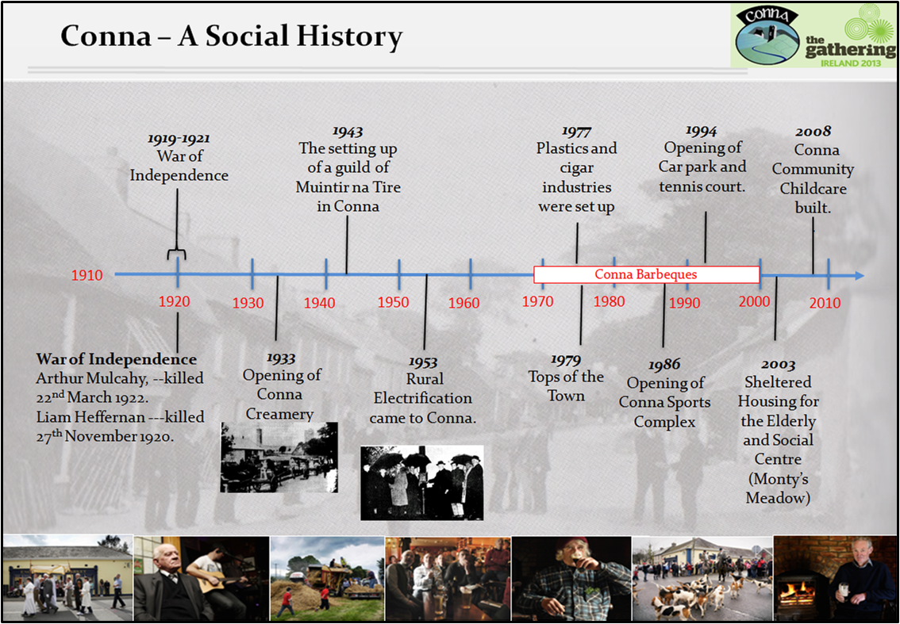
The War of Independence
Eaton Waters, doctor and writer, lived in Brideweir, during the War of Independence (1919-1921). He gives a comprehensive account of the attacks on the RIC barracks in Aghern and also the blowing up of Aghern Bridge.
Conna Bridge had its middle section damaged in the War of Independence.
Mogeely Bridge was also blown up during the conflict.
Two local patriots who lost their lives during the war were Arthur Mulcahy and Liam Heffernan. On the night of March 22nd 1921 a lorry load of British military forces and Black and Tans from Fermoy barracks called to the Mulcahy homestead in Currabeha. They singled out 22 year old Arthur and left. A short while later he was shot dead on the Clashagannive road. A monument to his memory now stands at the spot. He is buried in Tallow churchyard.
Liam Heffernan was born in Curraglass, Conna in 1898. He was employed as a chauffeur in Midleton. On the evening of November 27th 1920 he was in a car in Castlemartyr and a member of the RIC recognised him and in the ensuing gun battle Heffernan was fatally wounded. He was driven back to Conna but was dead on arrival.There is a monument to his memory in Knockmourne Cemetery and also one in Castlemartyr, close to where he was shot.

Conna Creamery
The first farmer-owned Co-operative Creameries were established in the late 1800s and early 1900’s. Basically the Creamery separated the cream from the milk. The cream was then processed into butter and the skimmed milk given back to the farmers to be fed to calves etc.
After a lot of meetings, planning and canvassing, Conna Co-operative Creamery, a branch of Castlelyons Co-op, was officially opened on June 1st 1933. In 1934 a large store was built to sell fertilizers and feedstuffs.
Conna was a good dairy district and local farmers traditionally made butter at home. However, having seen the returns from this type of butter making compared to the creamery prices in Castlelyons, farmers were determined to have a creamery branch of their own.
In 1968 bulk tank lorries began collecting milk and delivered it directly to Castlelyons Co-operative Creamery. This started a gradual phasing out of churns and mobile bulk tank trailers.
Conna Creamery fulfilled two functions for the farmers of the locality. It paid them for their milk but it also met a social need. Before the 1930’s, farming tended to be a lonely existence for the farmer. He worked all day, sometimes in a remote area, and rarely had an opportunity to socialise. When the Creamery was opened he took his milk there on a daily basis and conversed with the Creamery staff and other farmers. Often he would also call to a shop or Post Office buying groceries and the daily newspaper.
The Community Hall
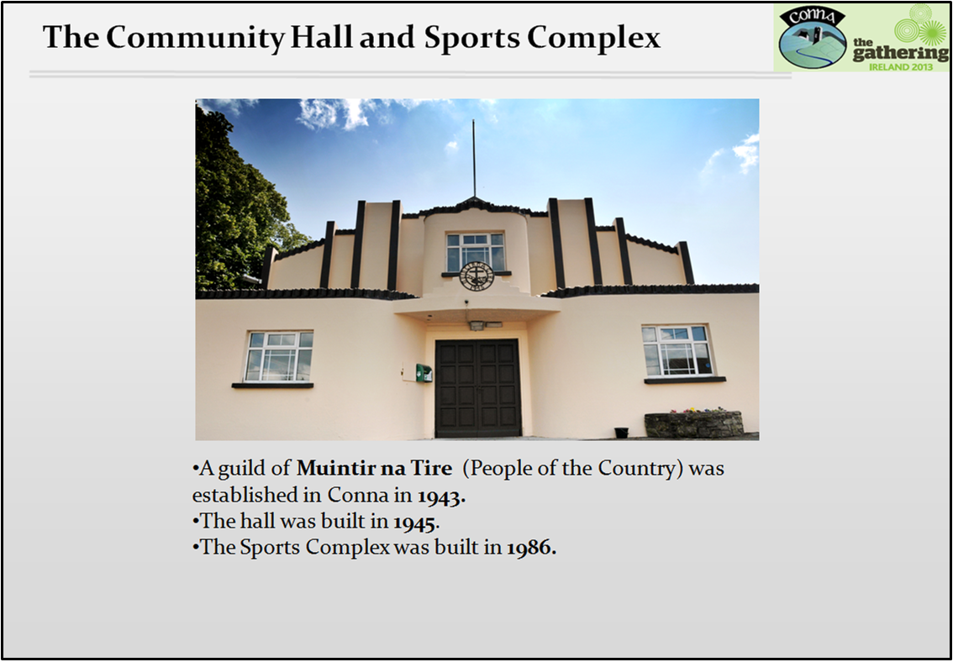
In 1943 a Guild of Munitir na Tire was set up in Conna. Muintir na Tire is a national voluntary organisation dedicated to promoting community development. It was founded in 1937 by Canon John Hayes. One of the first priorities of the new Guild was to build a hall where local people could meet for social, sporting and recreational activities.
A plot of ground, on which once stood a thatched church, was donated by Joseph Barry. The structure was built by direct labour with approximately 75% of it voluntary. It was officially opened by Canon Hayes on Saturday 8th December 1945.
So successful was the role played by the hall in the life of the local community that, eventually, in the late 70’s and early 80’s, the idea of expanding the capacity of the hall was discussed. Late in 1981, with this in mind, Conna Community Council purchased land from industrialist R.J. Kowenberg.
The Council embarked on a major fundraising drive in early March 1984. Members’ draws were started. Also, a government grant was obtained from the Department of Labour in 1985 for £75,000 on condition that the Council could raise £100,000 by September 1st of that year. With extraordinary generosity this money was raised through donations and interest-free loans. The Sports Complex was built by Council member Dave Feeney. It was opened on Sunday October 26th 1986.
A car park and tennis court was constructed in 1994 to complete the development.
Rural electrification
In January 1947, Oldtown, Co Dublin became the first village in Ireland to be electrified. In August 1948, Ballyduff was switched-on and it was reported that it attracted people from all parts of the district, including Conna.
The Conna Guild of Muintir na Tire put in long hours and hard work to bring electrification to the area. They carried out preliminary assessments of demand for electricity. If the response was good an official canvas was then carried out by an Area Organiser who measured the premises and determined the fixed charges. Then the householders would sign official application forms.
The Guild experienced a lot of frustration and disappointment because at first there was not sufficient interest amongst the householders and there were many defaulters. However, eventually when the benefits of electricity were explained, people who had formerly been dubious changed their minds and Conna’s name was put on the waiting list for wiring up.
Finally, on a wet evening on Wednesday April 29th 1953 Rev. Richard Thornhill P.P. depressed the switch which sent the current to 160 houses in the 22 square mile area. An enjoyable social function, which included speeches, dancing and refreshments, was held in the hall afterwards. In early May demonstrations were held in the hall explaining the usefulness of appliances such as cookers, Burko Boilers, washing machines, refrigerators, kettles, irons, pressure pumps and radios. Sales were reported as being very good.
The children of the locality had their own special reason for rejoicing at the switch-on; ice cream became available in the shops for the first time!

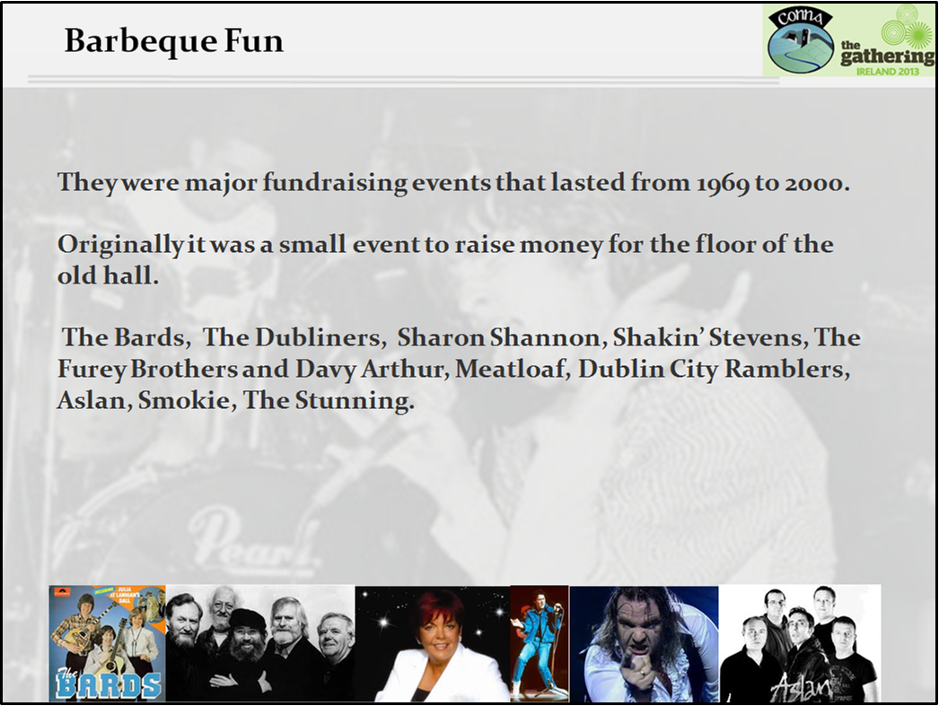
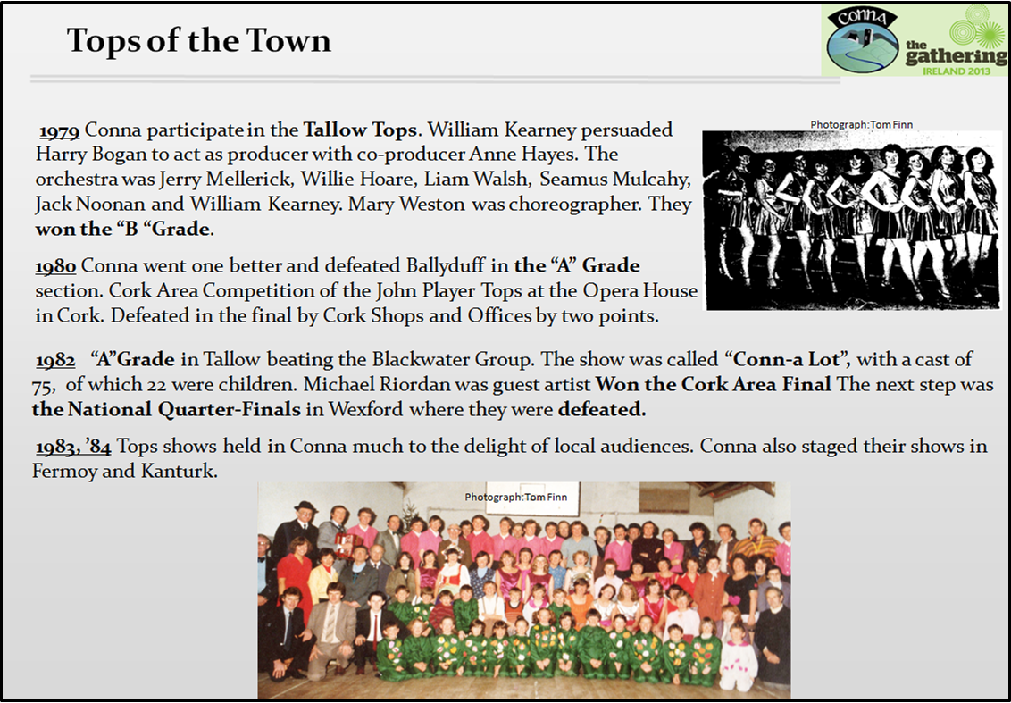
1979 Conna invited to participate in the Tallow Tops. William Kearney persuaded Harry Bogan to act as producer with co-producer Anne Hayes. The orchestra was made up of Jerry Mellerick, Willie Hoare, Liam Walsh, Seamus Mulcahy, Jack Noonan and William Kearney. Mary Weston was choreographer. They won the “B “Grade.
1980/81 Conna went one better and defeated Ballyduff in the “A” Grade section. Took part in the Cork Area Competition of the John Player Tops at the Opera House in Cork. They were defeated in the final by Cork Shops and Offices by two points.
1981/82 won the “A”Grade section in Tallow beating the Blackwater Group. The show was called “Conn-a Lot”, with a cast of 75, of which 22 were children. Michael Riordan was guest artist. Competed in the Cork Area Final which they won. The next step was the National Quarter-Finals in Wexford where they were defeated.
1982, ’83, ’84 Tops shows held in Conna much to the delight of local audiences. Conna also staged their shows in Fermoy and Kanturk.

Places of interest in Conna
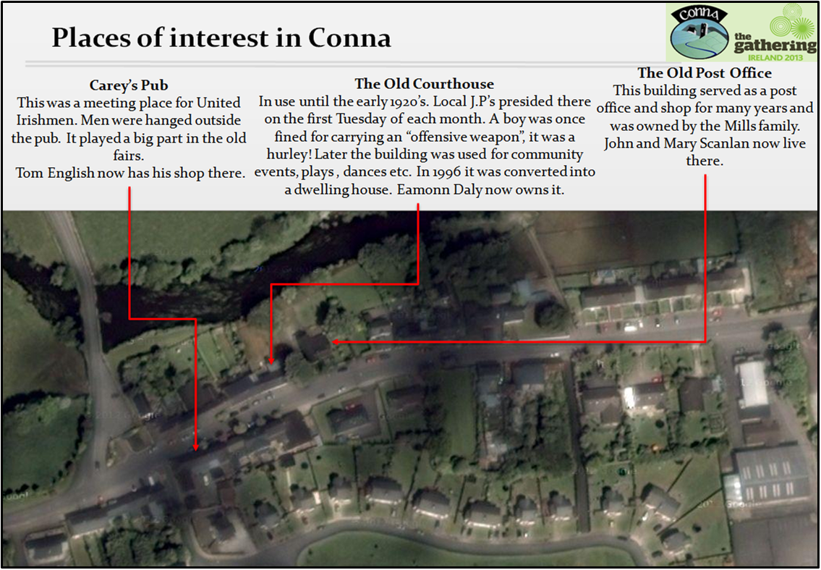
Carey’s Pub
This was a meeting place for United Irishmen. It was owned by Timothy Carey. Men were hanged outside the pub. It played a big part in the old fairs held in Pairc an Aonaig. Tom English now has his shop there.
The Courthouse
This was in use until the early 1920’s. Local J.P’s presided there on the first Tuesday of each month. A boy was once fined for carrying an “offensive weapon”, it was a hurley! Later the building was used for community events, plays, dances etc. In 1996 it was converted into a dwelling house by Mary Daly with her son Eamonn the current owner.
The Old Post Office
This building served as a post office and shop for many years and was owned by the Mills family. John and Mary Scanlan now live there.
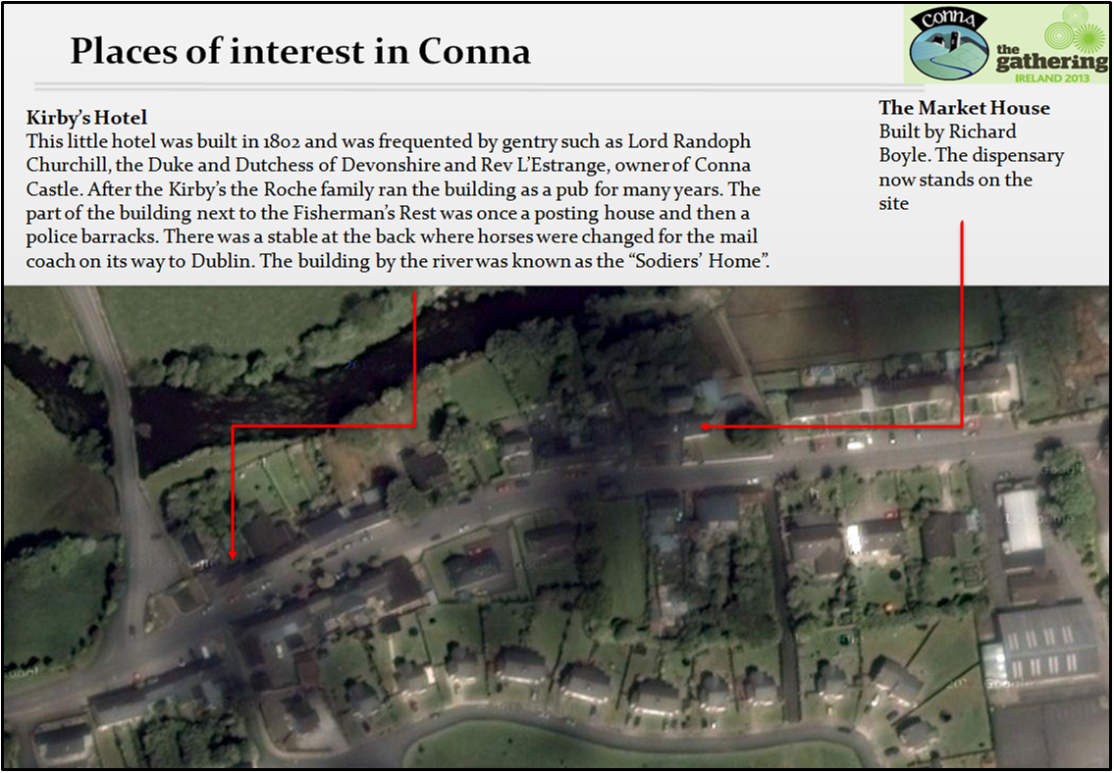
Kirby’s Hotel
This little hotel was built in 1802 and was frequented by gentry such as Lord Randoph Churchill (father of Winston Churchill), the Duke and Dutchess of Devonshire and Rev L’Estrange, owner of Conna Castle. After the Kirby’s, the Roche family ran the building as a pub for many years. The part of the building next to the Fisherman’s Rest was once a posting house and then a police barracks. There was a stable at the back where horses were changed for the mail coach on its way to Dublin. The building by the river was known as the “Sodiers’ Home”.

The Market House
This two-storey structure was built by Sir Richard Boyle, First Earl of Cork. The Dispensary now stands on the site.
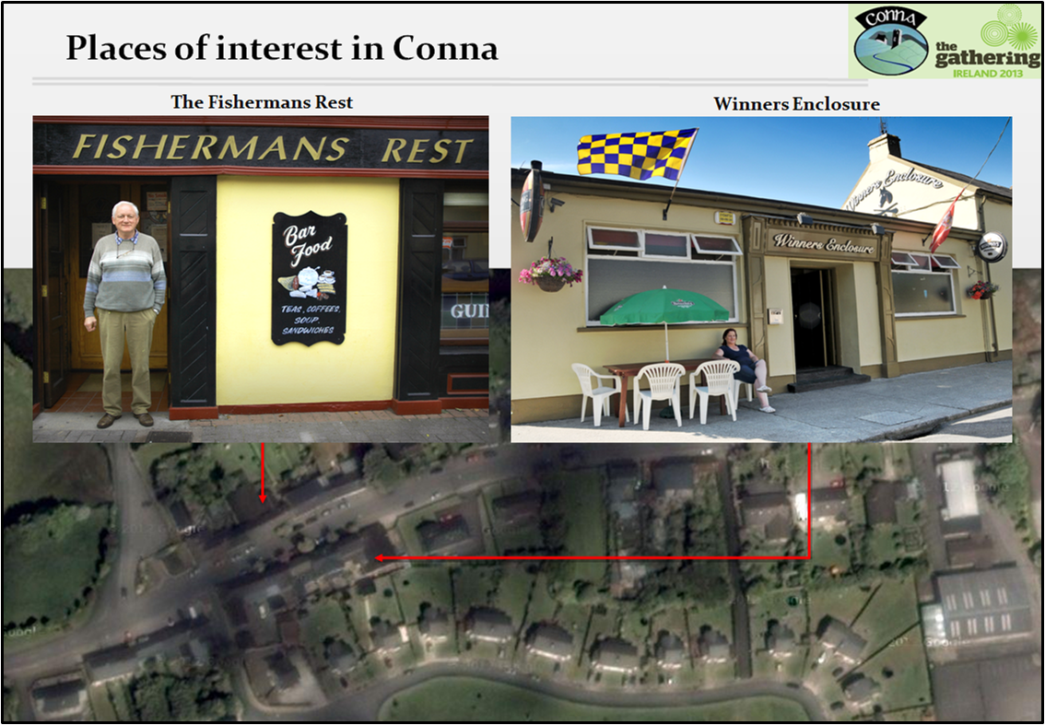

The Bridges
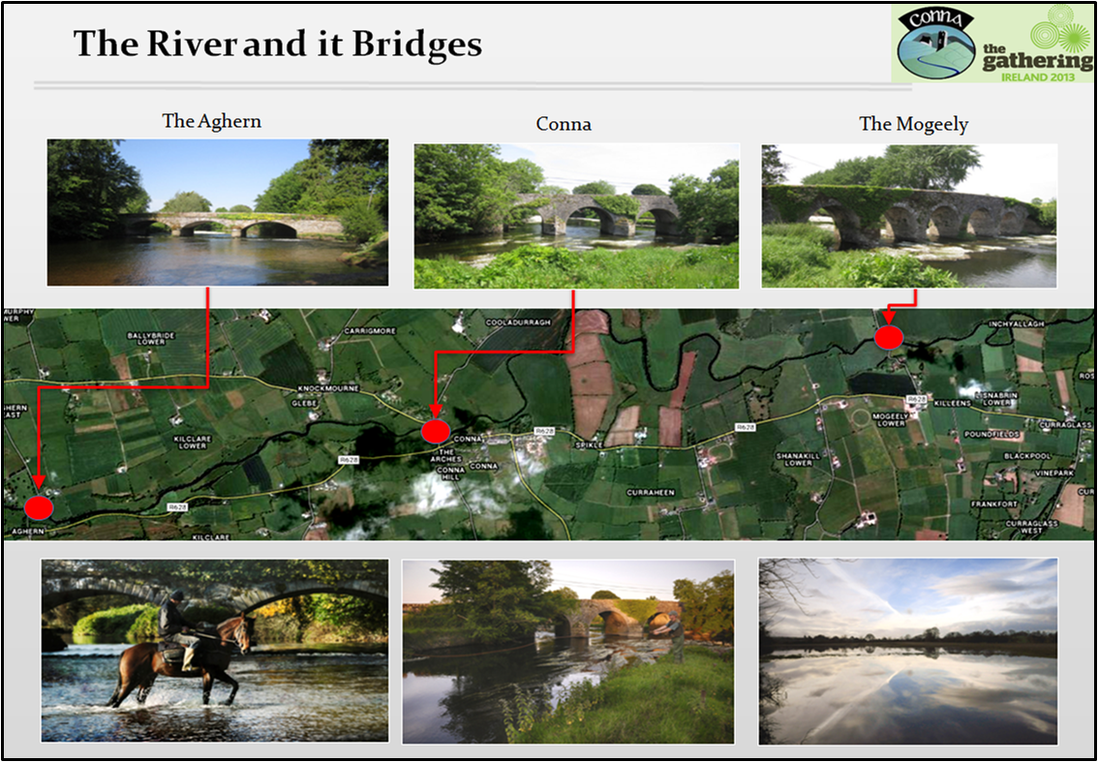
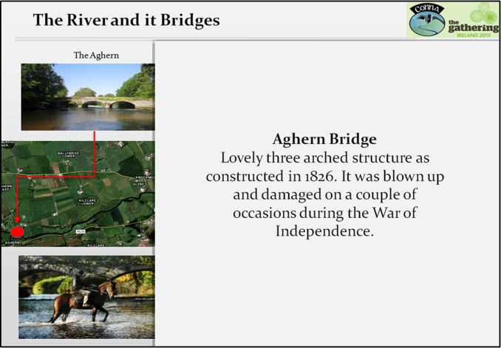
This was a three arched structure constructed in 1826. It was blown up and damaged on a couple of occasions during the War of Independence and again in the Civil war
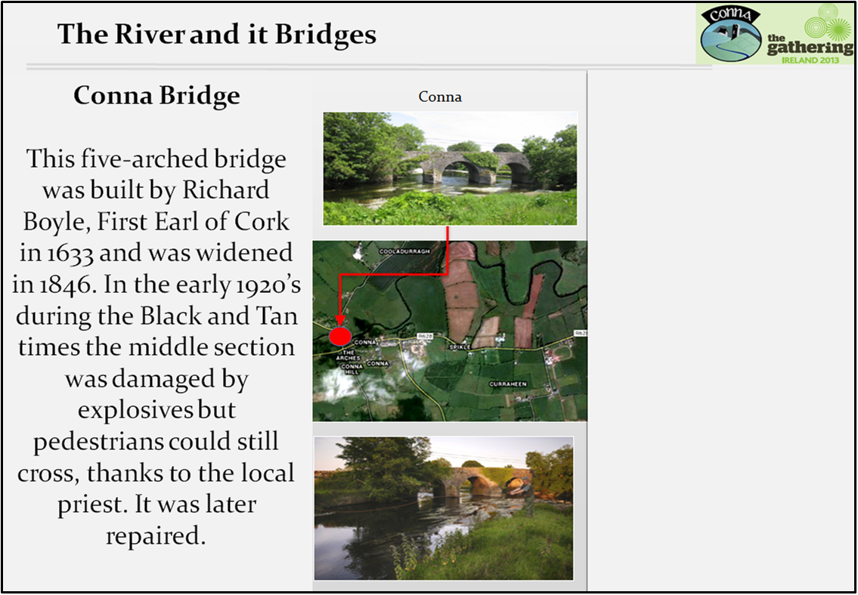
This five-arched bridge was built by Richard Boyle, First Earl of Cork in 1633 and was widened in 1846. In the early 1920’s during the Black and Tan times the middle section was damaged by explosives but pedestrians could still cross. It was later repaired. It is reported that the IRA came to completely demolish the bridge at one stage but Canon John Murphy stood on it and said “If you blow up the bridge then you blow up me as well”. The IRA then withdrew.
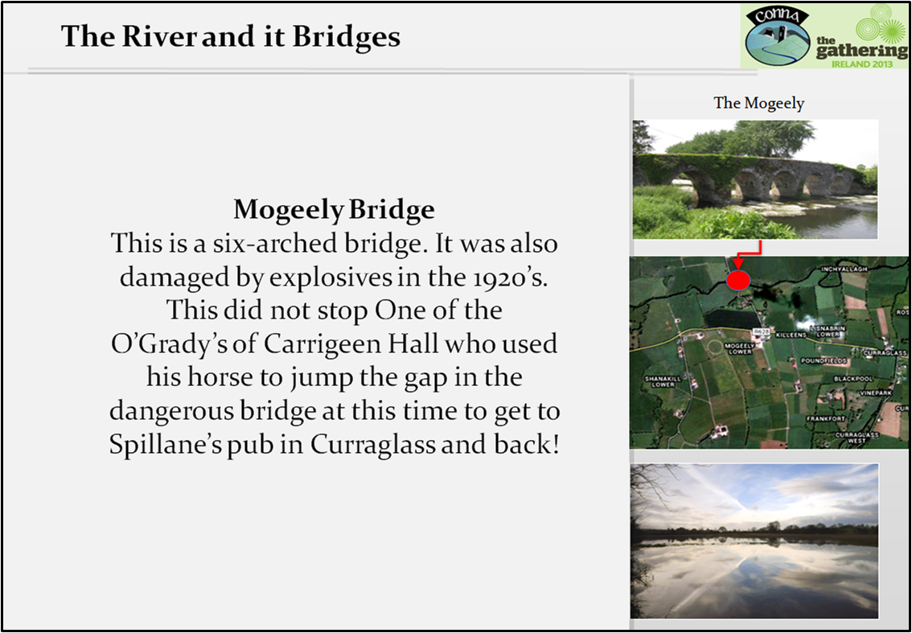
This is a six-arched bridge. It was also damaged by explosives in the 1920’s. One of the O’Grady’s of Carrigeen Hall used his horse to navigate the dangerous bridge at this time to get to Spillane’s pub in Curraglass and back safely, however drunk!

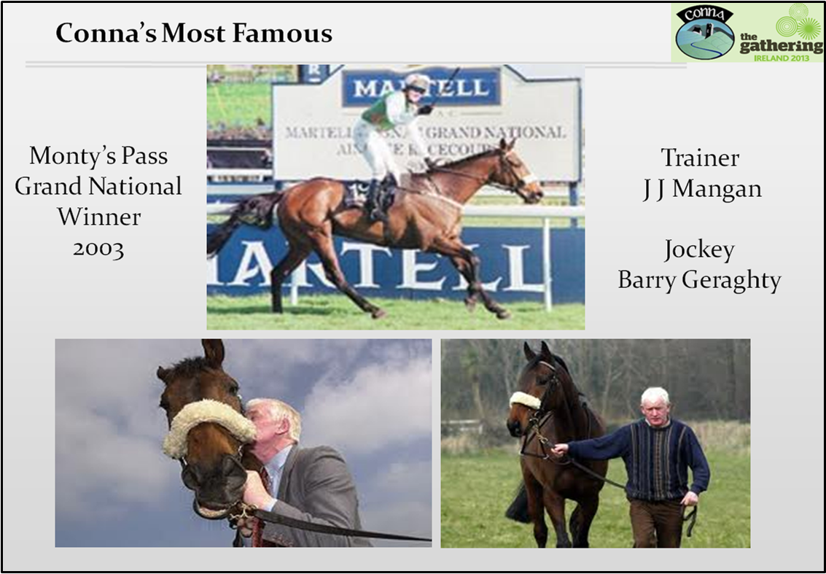
Monty’s Pass
Monty's Pass was the winner of the 2003 Grand National at Aintree, Liverpool, when ridden by Barry Geraghty, trained by Jimmy Mangan and running in the colours of the Dee Racing Syndicate. His price tumbled from 40/1 to 16/1 just before the race. Monty's Pass finished fourth in the defence of his title in 2004 and completed the course again in 2005 before being retired to Jimmy Mangan’s yard in Conna.
Stroll Home
On Wednesday July 30th 1997 a 7 year old chestnut gelding called Stroll Home won the Galway Plate. He was owned and trained by Jimmy Mangan and ridden by Paul Carberry. Later the great horse injured himself and had to be put down. He is buried under the Mangan’s front lawn.

